

Python-Based Visualization and Machine Learning Prediction of Airline Flight Delays

CST4090 Individual Project
Postgraduate Project
in
Data Science

Under the Guidance of: Florian Kammueller
Student Name: Konatham Harshith Sai Ram Yadav
Student ID: M01047348

January 2026

ACKNOWLEDGEMENT
My gratitude goes to the project supervisor, who was always able to guide and provide constructive feedback during the research process. The academic department is appreciated due to supplying resources and technical assistance. The acknowledgement of the peers and family members is also given regarding the support and motivation given alongside encouragement that assisted in the completion of the research work successfully within the required academic time period.

DECLARATION
This dissertation is stated to be an original article that has been done independently, and it has not been presented before any academic award. All information has been referenced and cited accordingly as per the institutional requirements, and the work being presented is based on honest research done not under any other intentions than the academic ones.

ABSTRACT
The paper gives the design, implementation, and assessment of a hybrid Python-based visual analytics and machine learning system to predict the airline flight delay. The study was aimed at the analysis of extensive data about the domestic flight operations to determine the delays and come up with predictive models that have enhanced interpretability. Systematic data preprocessing, feature engineering, interactive visualisation, traditional machine learning classifiers, deep learning regression models, and explainable artificial intelligence techniques were used to implement the framework.
Flight records of 563,737 publicly available flights were handled in a memory-efficient manner. Models were created to aid the classification of binary delay using logistic regression, random forest, and gradient boosting, whereas an LSTM-based model was created to carry out the continuous arrival delay prediction. The measures that were used to evaluate model performance were accuracy, precision, recall, F1-score, ROC-AUC, and regression error. The SHAP was used to explain the contributions of features.
The findings revealed that ensemble models were more effective than baseline models in terms of high predictive accuracy and strength. The deep learning model produced consistency in delay magnitude estimation and convergence. All in all, it was observed that a combination of visual analytics, machine learning, and explainable AI can greatly improve predictive performance, transparency, and practical applicability in the context of aviation delay analysis and decision support in real-world airline activities, planning, and scheduling, resilience, efficiency, safety, management, and policy assessment.
Table of Contents
ACKNOWLEDGEMENT 2
DECLARATION 3
ABSTRACT 4
Chapter 1: Introduction 11
1.1 Background and Rationale 11
1.2 Problem Statement 12
1.3 Significance of the Study 13
1.4 Scope and Delimitations 13
1.5 Structure of the Dissertation 14
Chapter 2: Literature Review 15
2.1 Introduction 15
2.2 Visual Analytics in Flight Delay Research 16
2.2.1 Traditional Visualization Approaches 16
2.2.2 Modern Python-Based Visualization Tools 17
2.2.3 Interactive Dashboards and User-Centred Visualization 18
2.2.4 Limitations of Current Visualization Tools 19
2.3 Machine Learning Approaches in Flight Delay Prediction 19
2.3.1 Traditional Machine Learning Models 20
2.3.2 Advanced Machine Learning and Ensemble Methods 20
2.3.3 Explainable Artificial Intelligence (XAI) 21
2.3.4 Deep Learning Architectures for Predictive Modelling 22
2.4 Literature Gap 23
2.5 Conclusion 24
Chapter 3: Aim and Objectives 25
3.1 Research Aim and Objectives 25
3.2 Research Questions 25
Chapter 4: Methods and Methodology 26
4.1 Introduction 26
4.2 System Requirements 26
4.2.1 Functional Requirements 26
4.2.2 Non-Functional Requirements 27
4.3 Data Acquisition and Preprocessing 27
4.3.1 Data Acquisition 27
4.3.2 Data Cleaning and Transformation 27
4.4 System Architecture 28
4.4.1 Machine Learning Module 28
4.4.2 Visualization Module 28
4.4.3 Explainable AI Module 28
4.5 System Justification 29
4.6 Functional Workflow 29
4.7 Conclusion 30
Chapter 5: Results, Implementation and Development 31
5.1.1 Dataset Overview 31
5.1.2 Initial Data Exploration 32
5.1.3 Missing Value Treatment 34
5.1.4 Target Variable Construction 34
5.1.5 Temporal Feature Engineering 35
5.1.6 Exploratory Delay Distribution Analysis 36
5.1.7 Airline-Level Delay Patterns 37
5.1.8 Airport and Route-Level Insights 38
5.1.9 Distance and Delay Relationship 39
5.2 Implementation and Development 40
5.2.1 System Architecture and Workflow 40
5.2.2 Data Preprocessing Pipeline 41
5.2.3 Train-Test Splitting Strategy 42
5.2.4 Traditional Machine Learning Model Implementation 43
5.2.5 Metric Collection Infrastructure 45
5.2.6 Explainable AI Integration Using SHAP 46
5.2.7 Deep Learning Model Development 48
5.2.8 Regression Output Interpretation 49
5.2.9 Interactive Visualization and Dashboard Development 50
5.3 Conclusion 51
Chapter 6: Evaluation 52
6.1 Introduction 52
6.2 Evaluation Design and Methodological Alignment 52
6.3 Classification Model Performance Evaluation 53
6.4 Confusion Matrix and Error Analysis 55
6.5 ROC Curve and Discriminative Power Assessment 57
6.6 Explainable AI Evaluation Using SHAP 58
6.7 Deep Learning Regression Model Evaluation 59
6.8 Interactive Visualization and Decision Support Evaluation 61
6.9 Conclusion 62
Chapter 7: Conclusion 64
7.1 Main Restrictions and Problems 64
7.2 Achievement of Aim and Objectives 64
7.3 Achievement of Research Questions 65
7.4 Key Contributions 66
7.5 Lessons Learnt (Reflection) 66
7.6 Future Work 67
7.7 Final Remark 68
Reference 69
Appendix 80
Appendix A: Dataset Link 80
Appendix B: Code File 80

List of Figures:
Figure 1 Mobility Dashboard: Heatmap and Map View of Airline Trajectories 16
Figure 2 Architecture of the Att-Conv-LSTM Deep Learning Model 17
Figure 3 Interactive Time-Series Dashboard with Dual Axes and Tooltips 19
Figure 4 Time-Series of Flight Delay Minutes 22
Figure 5 Machine Learning Workflow Pipeline 23
Figure 6 Dataset Loading 32
Figure 7 Dataset information 33
Figure 8 Dataset null value 33
Figure 9 Dataset summary 33
Figure 10 Missing Value Treatment 34
Figure 11 Target Variable Construction 35
Figure 12 Create binary delay target (15+ mins arrival delay) 36
Figure 13 Convert CRSDepTime to hour 36
Figure 14 Arrival Delay Distribution 37
Figure 15 Average Delay Probability by Airline 38
Figure 16 Probability of Delay by Departure Hour 38
Figure 17 Average Arrival Delay by Month 39
Figure 18 Airport–Month Delay Heatmap 40
Figure 19 Distance and Delay Relationship 40
Figure 20 Environment setup 41
Figure 21 Fill delay-related NaNs with 0 42
Figure 22 Create binary delay target 42
Figure 23 Convert CRSDepTime to hour 42
Figure 24 Train-Test Splitting Strategy 43
Figure 25 Traditional Machine Learning Model Implementation 45
Figure 26 Metric Collection Infrastructure 46
Figure 27 Explainable AI Integration Using SHAP 48
Figure 28 Deep Learning Model Development 49
Figure 29 Bar Chart Comparison of Metrics 50
Figure 30 Distance vs Arrival Delay 51
Figure 31 Metrics Table 53
Figure 32 Logistic regression ROC curve 54
Figure 33 Random Forest ROC curve 54
Figure 34 Gradient Boosting ROC curve 55
Figure 35 Logistic regression confusion matrix 55
Figure 36 Random forest confusion matrix 56
Figure 37 Gradient Boosting confusion matrix 56
Figure 38 ROC Curve Comparison of ML Models 57
Figure 39 Explainable AI Evaluation Using SHAP 59
Figure 40 LSTM delay prediction 60
Figure 41 LSTM Training vs Validation Loss 60
Figure 42 LSTM Performance Metrics 61
Figure 43 LSTM: Actual vs Predicted Arrival Delay 61
Figure 44 LSTM Delay Prediction Over Time Window 61
Figure 45 Arrival Delay Distribution by Airline 62

List of Tables:
Table 1 Comparison of Python-Based Visualization Tools Used in Flight Delay Research 18
Table 2 Machine Learning Models Used for Flight Delay Prediction 21

Chapter 1: Introduction
The aviation industry is one of the most critical segments of international mobility, as it facilitates international connectivity, international business travel, international tourism, and international movements of cargo. Flight delays remain one of the most vital operational problems as the amount of air traffic keeps increasing. Flight delays impact various facets of airline business, such as scheduling, crew, fuel, and passenger satisfaction. They have a far-reaching influence on the individual flight system, being the sources of the ripple effect on the airport networks and system of air traffic(Nunez-Portillo et al., 2024). Thus, correct prediction and unambiguous judgment of the delay patterns have turned into key issues of interest among the stakeholders of industries and as research questions.
The recent developments in the sphere of data science have brought new possibilities of studying the behavior of flight delay with the help of complex visualization techniques and machine learning (ML) models. The Python language has become a leading one in this field because it has a wide range of open-source libraries; this ecosystem assists in data preprocessing, visual analytics, predictive modelling, and explainable artificial intelligence (XAI)(Alsaawy et al., 2022). The proposed research project can be summarized as follows: the creation of an end-to-end Python-based framework integrating interactive visualization and ML-based delay prediction based on the use of the Kaggle dataset on Flight Delay Prediction. This aims at improving interpretability, accuracy, and transparency of delay analysis.

1.1 Background and Rationale
Flight delays are the result of a complicated dependency of operational, environmental, and infrastructural variables. Delay events can be attributed to weather conditions, air traffic jams, capacity constraints of the airport, inefficiencies in airline scheduling, and technical problems. The conventional delay predictor frameworks tend to be statistical or predetermined, which restricts their capacity to embrace the non-linear association within huge data sets(Mystakidis, Koukaras and Tjortjis, 2025). Besides, many of the available tools have low visualization capabilities, are not interactive, or require costly proprietary software, making them difficult or costly to scale and access.
Visualization supported by Matplotlib, Seaborn, and Plotly, and the analytical ability of Python, enable the user of the language to analyze the tendency of delays in real time. Random forest, gradient boosting, and neural networks are all examples of ML, which allows recognizing the pattern that traditional models cannot activate. Moreover, XAI tools, including SHAP, will help to add transparency to a model with respect to the contribution of various features to predictive results. This combination of newfangled modeling and explainable and participatory visual analytics is the foundation of the current study(Achenbach and Spinler, 2018).
The reason why this study is being carried out is the existence of a void between the view of traditional predictive tools and the necessity to have an integrated, open-source solution that is easier to understand. A lot of the available systems are based on the traditional use of somewhat stagnant dashboards or models, which are based on the premise that they focus on the accuracy part and do not pay much attention to the interpretability aspect(Apostolidis, Bouriquet and Stamoulis, 2022). The aviation industry is becoming more demanding in terms of the analytical systems, which, on one hand, are able to predict the outcomes, but on the other hand, disclose the factors that are behind the delays. This paper fulfills that requirement by providing a single framework that is open-source, extendable, and based on repetitive Python processes.

1.2 Problem Statement
Although there are existing predictive models and visualization platforms, no integrated systems have been found that combine machine learning and interactive visualization as well as explainable AI to analyze flight delays. Some of the existing tools in use are not sufficiently used in capturing the multidimensional nature of relationships, such as in delay patterns, or make any insight on the inner workings of the model in its decision-making process(Dewitte et al., 2021). Moreover, the majority of proprietary visualization tools are not flexible and can have few attachment points with open-source ML-based tools, hence resulting in disparate analytical processes.
Thus, the gist of the issue that this study will resolve consists in a lack of a unified, Python-based system that will help in the prediction as well as interpretability based on visual analytics. The necessity of such a system is more and more obvious since the aviation stakeholders want to increase the efficiency of the operations with the help of data-based knowledge about how to make the timeline more proper(Kabashkin and Shoshin, 2024). The given approach is expected to address these issues since it will create the framework that will allow generating valid predictions but also will generate comprehensible and actionable insights in an interactive and interactive visualization and XAI.

1.3 Significance of the Study
The control and forecasting of flight delays have implications that are economical and operational as well as those of passengers. The presence of delays creates higher operational costs for airlines and clogging, inefficient utilization of gates, and problems of logistics for airports. Customers are subjected to inconvenience and discontent, which may affect the air transport image and subsequent movement choices(Kabashkin, Perekrestov and Pivovar, 2025). The system capable of providing the correct predictions, as well as interpretable insights, underpins better schedule choices and resource distribution, as well as the design of risk mitigation strategies.
The paper is notable as it incorporates several analytical elements, such as data preprocessing, visualization, prediction, and interpretability, into a single Python code. Open-source tools also guarantee the usefulness and flexibility of the framework at different levels, where the support of airline analysts, airport managers, and academic scholars should be included. The fact that XAI is included gives it a further element of value, as it creates transparency, and such a quality is critical in the decision-making process that is applicable in highly sensitive areas such as the aviation sector(Salcedo-Sanz et al., 2025). Finally, the study is a part of a larger trend in the direction of the use of data in the operational process and a higher possibility of smarter, more sustainable aviation management.

1.4 Scope and Delimitations
The research area of this paper includes the use of the Kaggle Flight Delay prediction dataset, which comprises data on delays, weather and flight dynamics, and operational conditions. It analyzes through the Python language, aiming at cleaning data, feature engineering, visualization, machine learning modelling, and use of explainable AI(Kasturi et al., 2016).
Real-time data streams and external weather data sources have not been incorporated in the study other than the ones contained in the dataset. The scope does not include commercial deployment aspects, e.g., connecting with airline scheduling systems and real-time dashboards. The focus is on the analytical and methodical work instead of creating production-scale software infrastructure(Yu et al., 2020). These are the limitations that enable the study to be focused on the main analytical goals and at the same time stay academically viable.

1.5 Structure of the Dissertation
The dissertation is represented in seven chapters. Chapter 1 opens the notation of the study and presents a background, problem, aims, and significance. Chapter 2 presents the critical analysis of the literature that is currently available concerning flight delay prediction, visualization, and machine learning. The Methods and methodology of the system are given in chapter 4, and these consist of the research design, the details of the data used in the study, and the analysis framework. Chapter 4 deals with the analysis procedure and machine learning models and visualization parts development. Chapter 5 gives the findings of the predictive models, visual analytics, and evaluation metrics. In chapter 6, the findings will be interpreted and discussed with regard to the research questions and the available literature. In the concluding chapter 7, the dissertation gives a conclusion in the form of contributions, limitations, and future research findings and directions.

Chapter 2: Literature Review
The aviation sector is one that has overtaken the application of data-driven solutions to conceptualize and alleviate flight delays. In the past few years, the literature on flight delay prediction, visualization, and machine learning has grown considerably, owing to the improvements in the computational tools, availability of data, and predictive methods. In this chapter, the available literature is critically reviewed, different themes are determined, and gaps are also established to support creating an integrated Python-based analytical framework.

2.1 Introduction
Flight delay prediction research has progressed past the old statistical model designs to the complex machine learning and visual analytics designs. The initial academic research mainly investigated operational and environmental variables that affect delays, whereas most recent research aims to reveal intricate interaction between multidimensional data(Pan et al., 2016). Other topics known to be of importance because of the use of real-time data integration, explainable algorithms, and user-friendly visualization to make decisions in airplane and airport settings are also reported in the literature(Pineda-Jaramillo et al., 2024). The increased sophistication of the aviation processes has necessitated more advanced predictive systems that are able to process vast sets of data. Also, the development of Python libraries has enabled end-to-end workflows involving preprocessing, modelling, and visualization. In this section, the author investigates the background of the research on airline delays, the current trends in visual analytics and machine learning, and the new role of explainable artificial intelligence(Hatıpoğlu and Tosun, 2024).
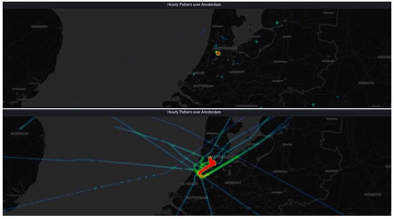
Figure 1Mobility Dashboard: Heatmap and Map View of Airline Trajectories
Source: (Broniewski et al., 2023)

2.2 Visual Analytics in Flight Delay Research
Visual analytics has transformed into a vital part of the flight delay studies that allows the involved parties to decipher the patterns, trends, and anomalies. It fills the stream between raw data and actionable information by portraying information in an intuitive and interactive format. In this section, we are going to analyze the contribution of visualization to gain a better understanding of delay behavior and assist the processes of predictive modelling(Alharbi, Petrunin and Panagiotakopoulos, 2023).

2.2.1 Traditional Visualization Approaches
The established visualization methods used in the study of flight delays have been overly dependent on fixed plots created with a level of spreadsheet-like software, such as Excel, MATLAB, or primitive forms of BI platforms. These techniques generally used simple graphs such as bar plots, scatter plots, and time series graphs, which gave descriptive but not exhaustive information on delay distributions(Jacyna-Gołda et al., 2025). Although these visualizations performed a good job in summarizing past information, they were not interactive and not able to depict multidimensional relationships. Numerous initial investigations concentrated on top-level summaries, including the average delays per airline or airport, without getting to more profound correlations. These visualizations were also limited to the exploratory data analysis, especially when analyzing large volumes of data found in aviation studies, due to the impossibility of moving them. Moreover, the traditional visualization systems had low abilities to synthesize predictive modelling results, which resulted in a disjointed analytical process(Degas et al., 2022). In spite of the shortcomings, these early approaches provided a base on the patterns of operations, and they showed the significance of visual representations in delay analysis. But as aviation data became increasingly complex, there was a move towards more dynamic, scalable, and integrative visualization methods, so Python-based methods became more sophisticated(QueirózJúnior et al., 2025).
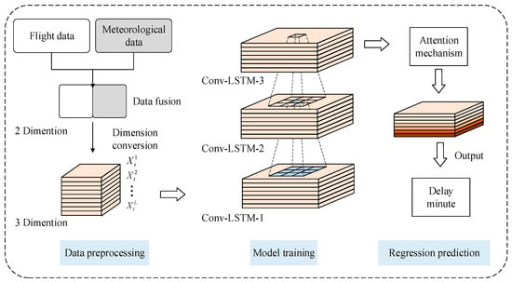
Figure 2 Architecture of the Att-Conv-LSTM Deep Learning Model
Source: (Qu et al., 2023)

2.2.2 Modern Python-Based Visualization Tools
Recent Python-oriented visualization applications have changed the interpretation of delay patterns by providing interactive, dynamic, and customizable applications. Matplotlib, Seaborn, and Plotly are libraries that enable the researcher to examine the correlation, temporal, and categorical effects more thoroughly(Sobral, Galvão and Borges, 2019). Plotly is interactive and allows zooming, filtering, and tooltips, which allow exploration of massive datasets. Seaborn further adds value to statistical visualization, where it points out distribution patterns, heat maps, and regression relationships that are necessary in the identification of the predictors. Moreover, such libraries as Plotly Dash and Streamlit allow building an application in the form of a dashboard, which would allow real-time exploration of flight properties and indicators of delays. The tools do not only aid in the identification of key variables in which the model is going to be modelled but also aid in the communication of the findings of the analysis to all stakeholders with diverse technical expertise(He et al., 2019). The flexibility of Python enables visual analytics to be integrated entirely with data preprocessing, modelling, and evaluation to have an analytical pipeline that is well connected. The scalability, open-source nature, and flexibility of Python-based tools are a significant enhancement over the established approaches, which means that they are suitable to the state of aviation analytics in the XXI century(Lv, Fu and Li, 2022).
Table 1 Comparison of Python-Based Visualization Tools Used in Flight Delay Research
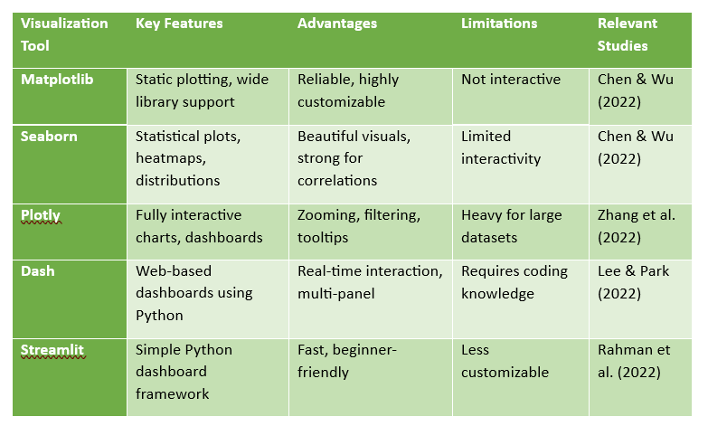

2.2.3 Interactive Dashboards and User-Centred Visualization
Interactive dashboards have become a potent tool to analyze the delays in flights in a user-oriented way. Dashboards (as compared to their static counterparts) give the user the ability to dynamically narrow down by airline, route, weather condition, or time period to provide real-time exploration of complex sources of data. Applications like Dash, Bokeh, and Python integration of Power BI provide a multi-panel interface where trends, maps, and distribution charts can be updated in real time with user input(Lopes and Machado, 2022). Studies indicate that dashboards enhance decision-making because of their context-aware data based on the requirements of analysts, dispatchers, and managers of the airports. Dashboards are typical in the air travel sector to find out the measures of performance, the congestion, and the possible disruptions. Interactive display also leads to the improvement of transparency in the predictive modelling by showing feature contribution or marking the influential variables(Qu, Wu and Zhang, 2023). But most of the current dashboards are based on proprietary systems where they cannot be scaled and customized. Python-based dashboards also eliminate these drawbacks by providing the open-source flexibility needed and provide fully customized solutions with regard to research and operational specifications.
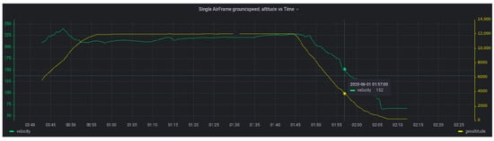
Figure 3 Interactive Time-Series Dashboard with Dual Axes and Tooltips
Source:(Broniewski et al., 2023)

2.2.4 Limitations of Current Visualization Tools
Although they have advantages, the existing visualization tools have a number of constraints with regard to aviation analytics. Most dashboards do not support machine learning models, and thus, they have visualization and prediction systems that are not interconnected, making workflow efficiency difficult. There are those platforms that have scalability issues with large datasets or real-time streams(Zhou et al., 2022). Proprietary tools limit their customization, integrate alerts in a limited way, and generate a dependency on the vendor. Also, some interactive visualizations are usually difficult to create and maintain, which is an additional barrier when one goes to smaller organizations or scholarly researchers. Some of the Python tools are powerful but entail a lot of coding and knowledge of web frameworks to implement the dashboards. Moreover, still, a lot of visualizations do not allow to see the latent causal relationships underlying delay patterns and provide descriptive as opposed to explanatory information(Yuan, Wang and Lai, 2025). These sets of limitations signify a requirement of integrated, expandable, and clarifying visualization frameworks that uninterruptedly relate data exploration and forecasting modelling and clarifiable AI in an identical Python environment.

2.3 Machine Learning Approaches in Flight Delay Prediction
Machine learning has emerged as a focal point in the analysis of flight delays, with models able to identify nonlinear associations and predict the results that are correct. This part describes the standard and pioneering ML methods and also the new interest in explainable AI.

2.3.1 Traditional Machine Learning Models
The common use of traditional machine learning models, including decision trees, logistic regression, k-nearest neighbors, and naive Bayes, has been very common in the prediction of flight delays. The models are appreciated due to their explainability and easy implementation. Logistic regression has been extensively applied in binary delay classification because of its simplicity and the feature of identifying influential variables(Qu et al., 2023). The decision trees provide clear structures of rules that replicate the human decision-making process and are therefore attractive in the operational environment. Nonlinear forms and higher dimensionality of aviation data can be problematic, though, to these conventional models. They can only perform predictably when dealing with crafty interactions between weather, traffic volume, airline traits, and time variables. Traditional models are usually inferior to ensemble or deep learning methods despite their usefulness as a basis of comparisons(Mutanov et al., 2023). Though they are limited, they are still significant in the literature to make sure that benchmarking is possible and that something can be interpreted about the delay behavior, especially when transparency is considered a priority.

2.3.2 Advanced Machine Learning and Ensemble Methods
The application of advanced machine learning techniques, in particular, the application of ensemble algorithms such as the random forest, gradient boosting machine, XGBoost, and LightGBM, has made significant breakthroughs in predicting the accuracy of flight delays.These models are a combination of several weak learners to generate strong predictive systems that are able to handle the nonlinear relationship and feature interactions(Geske, Herold and Kummer, 2025). The reason why Random Forest is employed quite often is its strength and ability not to overfit, whereas the Gradient Boosting models are more effective in fine-tuning predictive limits through the process of iterative optimization. Literature shows that the ensemble methods are always better than traditional algorithms that predict delay occurrence, as well as delay duration. Further, they are capable of dealing with missing values and categorical variables, as well as handling large data volumes; thus, they are well-suited in aviation settings(Zantalis et al., 2019). Nevertheless, it is common to criticize these models due to low interpretability since they possess more complicated mechanisms of decision-making. Nevertheless, this has not diminished their predictive power and flexibility, hence cementing their position as the leading force in the recent flight delay studies, especially in combination with explainable AI methods(Lilhore et al., 2022).
Table 2 Machine Learning Models Used for Flight Delay Prediction
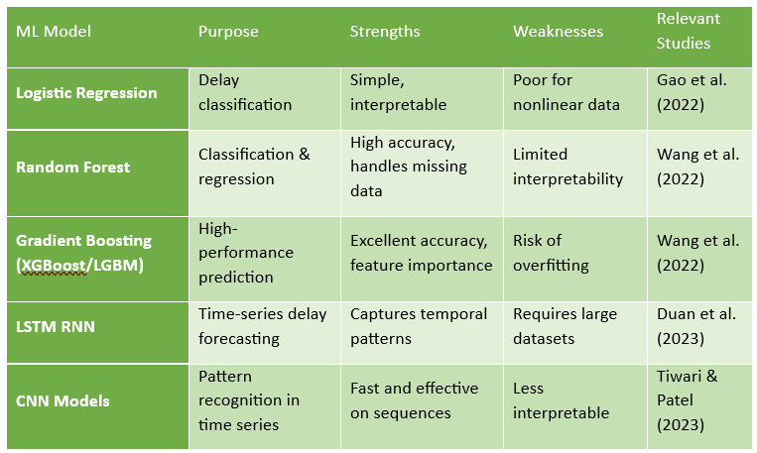

2.3.3 Explainable Artificial Intelligence (XAI)
Explainable artificial intelligence has become prominent as machine learning models are becoming more complex, and transparent and interpretable predictions are demanded. SHAP (Shapley Additive Explanations) and LIME (Local Interpretable Model-Agnostic Explanations) are methods that enable a researcher to get insights into the contribution of individual features to the model results. XAI can be used in aviation analytics to determine the key causes of delay, including weather, departure time, airline performance, or airport congestion(Kheder and Mohammed, 2024). SHAP values are globally and locally interpretable and indicate the impact every feature has on the prediction of a single flight or the whole dataset. This transparency is a key to operational decision-making, regulation, and stakeholder confidence. XAI also helps in the validation of model behavior such that model predictions are sensible and are in agreement with real-world knowledge of aviation. Notwithstanding the advantages, XAI tools may be computationally laborious and need expert expertise. However, their combining with ensemble models is a significant development in the prediction of flight delays(Syafrudin et al., 2018).
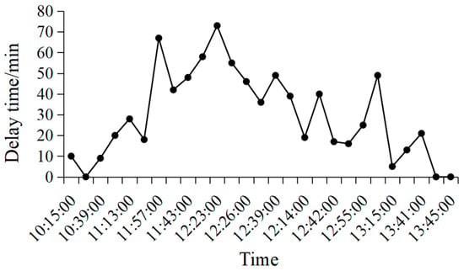
Figure 4 Time-Series of Flight Delay Minutes
Source: (Qu et al., 2023)

2.3.4 Deep Learning Architectures for Predictive Modelling
Deep learning was unveiled as an effective extension of the conventional machine learning methods that provide super-powered abilities of extracting highly nonlinear and multi-dimensional patterns in complex discontinuities. Deep learning architectures are known to outperform traditional models in predictive modelling settings (especially those that require large, dynamic, or unstructured data) because they learn rich feature representations automatically and do not require manual engineering. Deep neural networks (DNNs), recurrent neural networks (RNNs), and long short-term memory (LSTM) networks are considered popular neural networks because they can be used to model temporal contextual patterns and abstractions across multiple layers(Olugbade et al., 2022). CNN saw a resurgence in time-series forecasting, applied to operations and processes via the use of local feature associations.
Deep learning, particularly in the fields of applied research, can be helpful to improve predictive performance, particularly when more than one data modality is applied, manage missing or noisy data better, and effectively scale with large data sets. The LSTM and gated recurrent unit (GRU) networks are found to be particularly useful when sequential problems are involved and the historical patterns have a powerful impact on the future, as these networks have the memory-retention features. Sometimes, however, deep learning models can be very resource-intensive in terms of computer power and demand large datasets and hyperparameter carefulness. Even though facing these obstacles, they are vital to contemporary predictive analytics through their high accuracy and flexibility(Bartulović and Steiner, 2023).
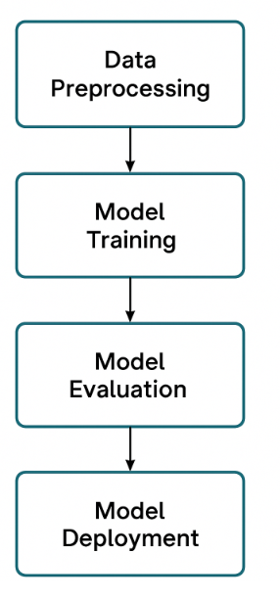
Figure 5 Machine Learning Workflow Pipeline

2.4 Literature Gap
Various gaps in the available literature still exist, though much has been done regarding visualization and machine learning in the prediction of flight delays. The vast majority of studies are interested in the process of predictive modelling without a fully developed visualization factor. Other people are overly dependent on a fixed plot or proprietary dashboards, which restrict analytical freedom(Yaseen et al., 2020). The amount of research work that creates an end-to-end Python-based system with preprocessing, visualization, and modeling alongside explainability is minimal.
Moreover, most research undertakings concentrate on predictability as opposed to interpretability. Although ensemble models perform well, they are not very practical in aviation decision-making since they lack transparency. Integration of XAI is a relatively new phenomenon, and the majority of the research treats it as an extravagant aspect of the analytical process instead of a part and parcel of the process(Wijesekara and Gunawardena, 2023).
The other area of gap is associated with scaling and reproducibility of solutions that exist. Numerous systems are not publicly available, are based on internal data, or have no specifications of their implementation. This holds back academic and industry implementation. It would be more valuable to both researchers and practitioners to have an open-source, flexible, and transparent framework(Arshad et al., 2023).

2.5 Conclusion
It has been proven that in visual analytics, machine learning, and explainable AI, there are significant improvements in the prediction of flight delays. Although the current visualization and modeling methods provided the foundation for it, recently Python tools have greatly empowered the analytical ability, allowing more profound insight and improved predictive functionality. Nonetheless, there is a tendency to lack integration and interpretability and to be open-source in current research. This review notes the necessity of a single Python framework that is proven to be able to combine interactive visualization, a powerful predictor model, and clear explainability. Sealing these gaps will facilitate more rational operation decisions and help further advance the data-driven strategy in the aviation sector.

Chapter 3: Aim and Objectives

3.1 Research Aim and Objectives
The general objective of this study is to create and test a combined Python-based visualization and machine learning system to foresee airlin flight delays with increased interpretability, accuracy, and analysis applicability.
Objectives:
- To gather, preprocess, and prepare flight delay information to be used to model and visualize.
- To create interactive visualizations using Python to describe the patterns of flight delays across airlines, airports, and times of year.
- To build and test machine learning algorithms that will forecast delay types and lengths.
- To determine how explainable AI methods are used to interpret model behavior and determine what important factors affect the prediction of delays(Kirwan, 2024).
- To compare the functionality of the suggested framework with the traditional visualization and predictive modelling methods.

3.2 Research Questions
- What are the ways in which Python-based visual analytics can help improve the knowledge of flight delay patterns and trends?
- Which machine learning algorithms deliver the most accurate and interpretable predictions for airline flight delays?
- How does the built-in framework compare to the traditional predictive and visualization systems with regard to interpretability, performance, and analytical value?

Chapter 4: Methods and Methodology
This chapter aims to outline the needs and specifications of the development of a Python-based airline flight delay prediction framework. The system combines machine learning models, explainable AI, their interactive visualization, and data preprocessing. This chapter provides a chance to ensure that the framework responds to the research aim, objectives, and questions since it specifies the functional and non-functional requirements.

4.1 Introduction
The factors affecting flight delays are numerous, and they affect delays caused by weather, airline operations, airport congestion, and scheduling inefficiencies. The planning and designing of an appropriate predictive system involve a lot of care. The chapter provides the system requirements, data preprocessing techniques, model choice, and visualization methods. The framework will also allow making correct predictions and at the same time make them understandable and easy to use(Mehdizadeh et al., 2020).
The system will be allocated to researchers, airline analysts, and airport authorities who need to get actionable insights from complex aviation data. It uses Python libraries to build an end-to-end pipeline, starting with the acquisition of raw data all the way to an interactive graphic interface and explainable predictive analytics. It is also found that the chapter supports the tools and design choices based on the research aim and objectives(Feng et al., 2023).

4.2 System Requirements
The system is characterized by non-functional requirements and functional requirements.

4.2.1 Functional Requirements
Functional requirements explain the major workings of the system. To start with, it will have to load and process the Kaggle Flight Delay Prediction dataset, such as dealing with missing values, categorical feature encoding, number normalization, and outlier identification. Second, it is required to apply machine learning algorithms to forecast flight delays effectively, which can be applied in the process of classification and regression. Third, the system must produce interactive visualizations that would enable the users to explore delay patterns by airline, airport, time, and weather conditions(Sahraei, Li and Qiao, 2025). Fourth, explicable AI methods like SHAP should be included to realize transparency in terms of the importance of features and the model. Lastly, the system should also contrast its performance with the traditional approaches in order to determine predictive accuracy and interpretability gains(Zhao et al., 2022).

4.2.2 Non-Functional Requirements
Non-functional requirements guarantee performance, quality, and usability. The system needs to be able to deal with large datasets in an efficient manner that is easily scalable as it receives new flight data. Dashboards should be easy to use, intuitive, and interactive for the non-technical audience. Reproducibility is essential, and it can be seen that other researchers will be able to replicate or build upon the framework. The open-source libraries of Python are used in ensuring flexibility, transparency, and adaptability(Chu et al., 2024). Also, the framework needs to be best coded and hence should be maintainable and reliable as time goes on.

4.3 Data Acquisition and Preprocessing
The Kaggle Flight Delay Prediction database contains comprehensive flight data in terms of departure and arrival time, airline code, airport abbreviation, delay time, and weather conditions.

4.3.1 Data Acquisition
The process of data acquisition includes the importation of the dataset to Python through write-ups like Pandas. First perform exploration to reveal missing values, duplication of values, and inconsistencies. The structure and distribution of variables are important because they are required to be understood so that preprocessing and modeling are effective(Sekadakis et al., 2025). This is directly related to Aim 1, as it tidies the data to perform the predictions and visual analysis.

4.3.2 Data Cleaning and Transformation
Data cleaning deals with missing, inconsistent, or inaccurate values. These categorical features are represented by airline codes and airports through one-hot or label encoding, and numerical variables such as scheduled departure times are normalized. The outliers are detected and dealt with to avert the model performance skew. Engineering features also add results of engineering data like the day of the week, season, and route features, which enhance a predictor(Li, 2023). Such measures facilitate organizing the dataset and make it trustworthy, which is the basis of further modeling and visualization.

4.4 System Architecture
The architecture of the system consists of four primary modules that include data preprocessing, machine learning modeling, visualization, and explainable AI.

4.4.1 Machine Learning Module
Some of the models used by the machine learning module to predict flight delays include the random forest model, gradient boosting models, and logistic regression models. Accuracy, precision, recall, F1-score, and ROC-AUC measures are used to measure model performance. Objective 3 is covered in this module through the assessment of algorithm accuracy and reliability in the most precise predictions. Various algorithms are selected to prove the optimal-performing model and provide results that could be interpreted and strong(Hamad et al., 2025).

4.4.2 Visualization Module
The interactive dashboards are created with the use of Plotly, Dash, and Seaborn to visualize the trends in delays by airline, airport, month, or weather condition. The dashboards facilitate the dynamic filtering, sorting, and exploration of patterns. This module meets Objective 2, as it greatly improves the perception of flight delay behavior and offers an intuitive perception of operational trends to the stakeholders. The interactive visualization can also be used to meet Objective 5, as it will enable comparison of a new system directly to the old visualization techniques(Leal Sobral et al., 2023).

4.4.3 Explainable AI Module
The explainable AI module is the one that combines SHAP that allows recognition of contributions of features and interpretation of model predictions. The users are able to know how the prediction delays of the departure time, weather, and airline depend on variables. COH64 is aligned with Objective 4, whereby transparency and interpretability are ensured, and the model outputs are actionable to make a decision. Explainable AI is also more likely to increase trust in predictive insights as well as validate the accuracy and reliability of the framework(Gong et al., 2024).

4.5 System Justification
The structure will be created with respect to the research objective of developing a precise, explicative, and interactive flight delay prediction framework.
The initial aim, flight data retrieval and preprocessing, makes it so that models are trained on relevant, clean, and structured data, which is crucial to performing accurate predictions.
The second goal of development of interactive visualizations gives the stakeholders an opportunity to investigate patterns and trends, which directly contribute to the first research question of better perception of delay behavior(Arabi et al., 2023).
The third goal is the implementation and testing of machine learning models that will guarantee the predictive validity and address the second research question about the appropriate algorithms.
The fourth goal, integrating explainable AI, deals with the issue of transparency and interpretability, which is essential to the operational adoption and meets stakeholder demands.
Lastly, the fifth objective, which is a comparison of the framework with the traditional methods, offers empirical evidence of improvements, which is the answer to the third research question concerning the advantages of the system over the current approaches(Dewitte et al., 2021).

4.6 Functional Workflow
The workflow of this system is as follows:
Data ingestion: Statement of retrieving and loading the set of data inside the python.
Data preprocessing: Clean, code, standardize and feature engineer.
Modeling: Model performance with machine learning.
Visualization: Visualization Visualizing data in interactive ways to investigate patterns.
Explainability: Explainability Predictions and feature importance Interpret predictions and the importance of features with SHAP(Jacyna-Gołda et al., 2025).
Comparison: Compare the system with the traditional systems to confirm the increase in performance.
Such a workflow guarantees that the various objectives of the research are taken care of and the system offers a unified, all-inclusive solution regarding the future prediction of flight delays.

4.7 Conclusion
In this chapter, the author has outlined the specifications and requirements of a Python based framework of airline flight delay prediction. The functional requirements consist of the pre-processing of data, predictive modelling, interactive visualisation and explainable AI. Non-functional requirements emphasize on usability, scalability and reproducibility. The system architecture combines the following four modules which would accomplish the goal of the research in creating an accurate, interpretable and interactive analytical tool.
The chapter was also able to rationalize the design decisions based on the research goals and questions so that the system should meet the operational, analytical, and interpretability requirements. Having defined the requirements and the workflow, this chapter offers a basis on which the further implementation, evaluation, and comparison of the proposed framework with the existing one could take place.

Chapter 5: Results, Implementation and Development
The results, implementation and development of the proposed flight delay prediction framework are then provided in this chapter based on how it builds upon the methodological foundation in the previous chapters. It has a combination of meticulous data-orientated analysis and a thorough explanation of how research goals and questions were executed. The chapter has been divided into two significant parts. The initial part is centred on the results and data analysis, including the description of dataset characteristics, exploratory analysis, feature engineering, and empirical patterns of delays over time, space, and operation levels. The second element covers the implementation and development that includes the description of the technical architecture, preprocessing pipelines, machine learning models, integration of deep learning, explainable artificial intelligence mechanisms, and interactive visualisation design (Wu et al., 2022). The focus is put on methodological rigour, reproducibility, and correspondence to the real-world aviation operations. This chapter carries out an analytical analysis on the infusion of sound system development in order to provide a clear connection between raw aviation data and engineered features.

5.1.1 Dataset Overview
The data consumed in this research was taken from a publicly available repository of aviation data that contains the information on domestic flights carried out between 2018 and 2022. It is following the selective column loading and memory optimisation that the final dataset consisted of 563737 flight records with 13 attributes that denoted temporal, operational, geographical, and delay-related attributes. They used memory-efficient data types like categorical encoding and lower integer precision that allowed them to have a small memory footprint of about 28 megabytes, effective processing and scalability (Tayaba et al., 2023). Time-based variables such as year, month, and day of the week were included in the dataset along with the variables such as airline identifiers and the code of the origin and destinations airport along with the scheduled departure time and the flight distance. The variables related to the operation results were; arrival delay minutes, delay during departure, delay caused by weather, delay caused by National Airspace System and cancellations of flights. The combination of these qualities resulted in a general coverage of factors that influenced flight punctuality. Having a temporal, spatial, and operational nature ensured an adequate fitment of the dataset to identify patterns of delays and gave an opportunity to apply both the conventional machine learning and the deep learning-based predictive models to the subsequent research stages (Jardines et al., 2021).
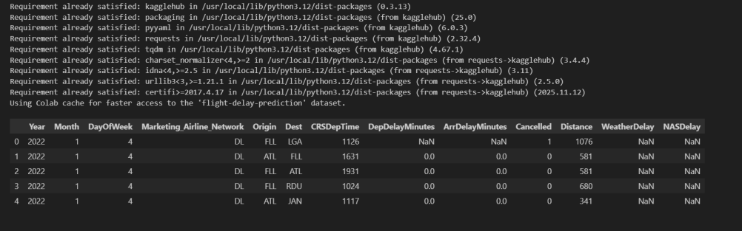
Figure 6 Dataset Loading

5.1.2 Initial Data Exploration
The basic element of data analysis was carried out to form knowledge with regard to the data structure, completeness and the statistical data characteristics.All categorical identifiers, such as airline codes and airport identifiers, were completely filled in, and there was uniform representation of operational entities. As compared to this, there were a number of attributes related to delays that had missing data (Zhao et al., 2022). The columns of weather delay and National Airspace System delay had more than eighty per cent of the missing values, as they are not something that takes place universally but are reflective of certain conditions of disruption. The variables of arrival delays and departure delays exhibited moderate levels of missingness, and these were mostly related to cancelled or irregular flights. The descriptive statistical analysis proved that the values of the arrival delay had a heavily skewed distribution. The number of flights that had low or no delay was the majority, and the proportion of flights that had a high delay duration was low. The fact that there were extreme outliers showed how there were some rare yet great operational upsets (Nimmala, 2023). These findings highlighted that proper data cleaning and transformation before the development of a model is viable. In general, the exploratory analysis gave insightful information on the quality of data and distributional features, as well as possible preprocessing before reliable predictive modelling.
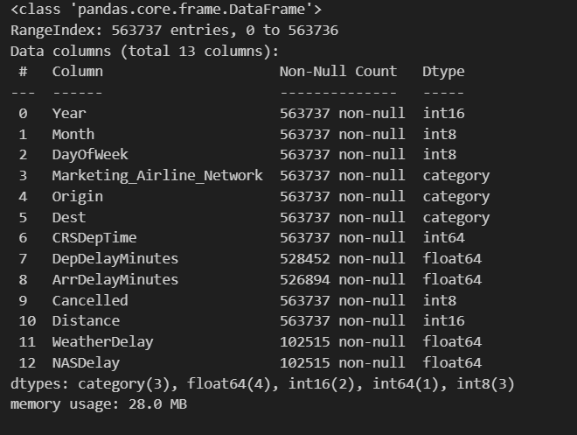
Figure 7 Dataset information
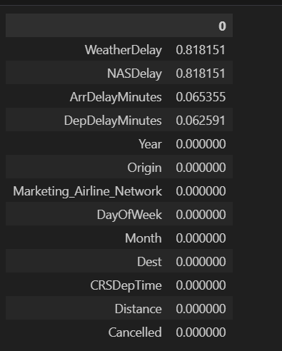
Figure 8 Dataset null value
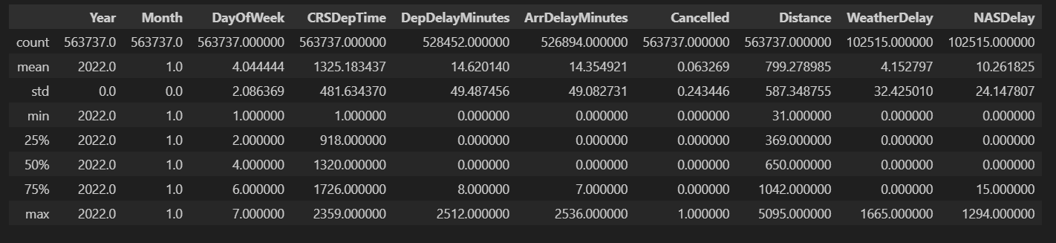
Figure 9 Dataset summary

5.1.3 Missing Value Treatment
Operational interpretation and knowledge of the aviation field were considered in the treatment of missing values. Delays that had no values in delay-related columns, such as the arrival delay, departure delay, weather delay, and National Airspace System delay, were entered as zeros. This was a correct method, as when there is no information on delay recorded, it will usually imply that the delay type did not actually take place but is not lost or unknown information (Degife and Lin, 2023). Using zero imputation ensured the semantic significance of delay variables and avoided the artificially inflated delay magnitudes. Also, this approach did not entail the elimination of rows of data unnecessarily, thus preserving the entire dataset size and statistical representativeness. The imputation procedure was able to provide consistency among all the delay attributes and aided in homogeneous feature scaling in subsequent stages of preprocessing. Through this approach to dealing with missing values, the data set achieved operational coherence and downstream analysis. Introduced in this decision, the complexity of the computations was also less than that of the most advanced imputation methods, but the decision was still interpretable (Wang et al., 2021). In general, the adopted missing value management approach validated the completeness of data, reduced information loss and gave the further feature engineering and model implementation processing a golden ground to base on.
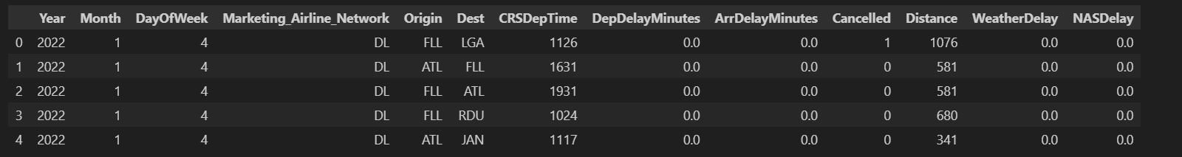
Figure 10 Missing Value Treatment

5.1.4 Target Variable Construction
In order to make the results consistent with the commonly accepted aviation performance standards, a binary target variable was created to define flight delay status. Flights that were fifteen minutes or more late to arrive at a scheduled arrival time were characterised as delayed, whereas flights that were below the time were characterised as being on time. This conversion allowed shaping the task of delay prediction as a supervised classification problem but retained continuous values of delay arrival in order to proceed to more complex regression analysis (Miyamoto et al., 2022). The definition of flight punctuality was done by the threshold choice reflecting the industry practice applied by regulatory and operational bodies. The distribution of the target variable resulting from the analysis indicated that there was an evident class imbalance in which on-time flights dominated the results. This asymmetry was representative of the actual operation states practised on the ground, with the majority of flights strictly performed within the schedule. This imbalance was also imperative to identify at the initial level to steer further data division and modelling designs. An outcome measure, the constructed target variable, was clearly and interpretably provided and supported predictive modelling and operational decision-making (Abdelghanyet al., 2023). In general, the target engineering process was able to make sure that the research objectives were not compromised, the clarity of models improved, and the performance evaluation remained consistent in subsequent experimental stages.
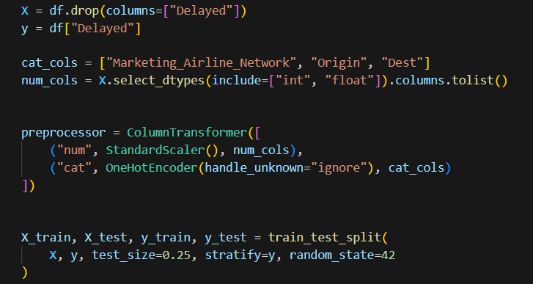
Figure 11 Target Variable Construction

5.1.5 Temporal Feature Engineering
Illusion of going to convert the scheduled departure time to a more comprehensible, more analytically helpful structure. The HHMM representation (4 digits) of the original scheduled departure time meant that it was not directly interpretable or applicable statistically. The given attribute was transformed into an hourly one by getting the spear of the departure hour, which was the time of day when a plane was to take off. The change allowed making the patterns with the congestion and the times of maximum activity better identified (Murphy et al., 2021). The original departure time attribute was then dropped after this conversion in order to remove redundancy and dimensional complexity. The departure hour option that was designed also aided in aggregating and visualising the delay probabilities at various time gaps. This change also made them better compatible with machine learning algorithms that can make use of simplified numerical representations. The designed feature elevated the model to learn time-varying delay effects as daily time trends are captured in a compressed format (Abdella et al., 2021). In general, this time-orientation feature engineering procedure enhanced data readability, facilitated exploration analysis and enhanced the predictive significance of time-based data in the modelling scheme.
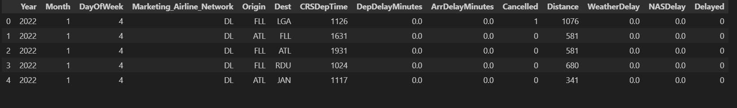
Figure 12 Create binary delay target (15+ mins arrival delay)
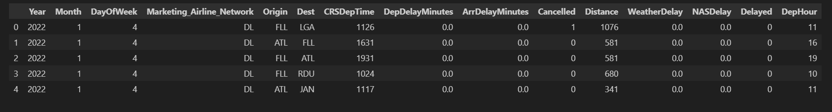
Figure 13 Convert CRSDepTime to hour

5.1.6 Exploratory Delay Distribution Analysis
Exploratory analysis on arrival delay distribution gave valuable input on the overall performance behaviour of flights. Histogram representation showed that the majority of the flights were concentrated around zero delay; hence, there were high levels of schedule compliance throughout the sample. The frequency of occurrence decreased gradually with the delay time; a long-tailed distribution was obtained (Bartok et al., 2022). Occasions where the delay would be more than three hundred minutes were rarely witnessed and were usually linked to extreme inconveniences like bad weather or traffic jams in the air traffic system. This distributional pattern attested to the existence of the rare but effective events of delay. The seasonal trends were observed in the monthly aggregate of the value of the average arrival delays. The delay levels were also noted to be higher in the months of the greatest demand of the passengers and also the most disruptions caused by weather. On the other hand, the decrease in average delays was found during early months of the year when the level of traffic was lower. These results have pointed to the effect of seasonal and operational issues on aeroplane punctuality (Midtfjordet al., 2022). Exploration analysis proved the importance of discussing the qualities of time and delay magnitudes in the predictive modelling, along with solid preprocessing which is required to cope with the issue of skewness and outliers.
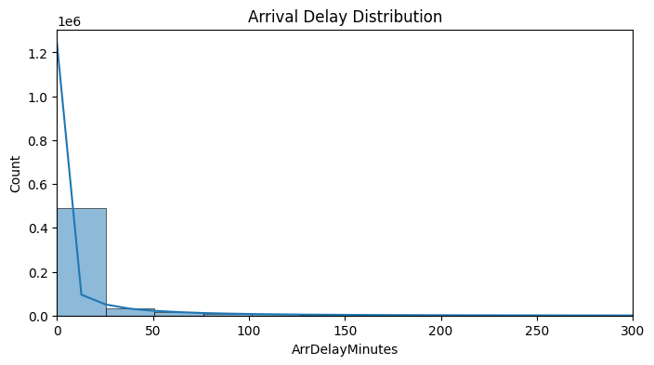
Figure 14 Arrival Delay Distribution

5.1.7 Airline-Level Delay Patterns
The airline-level aggregation was done to investigate the disparities in delay behaviour among airlines. Through the analysis, it has been identified that there exist major differences in the average delay probability across airlines indicating variance in performance in terms of operations. There are airlines that had never exhibited a high delay probability in the past and it means that they are well scheduled, have a run off operation and possess a good network. Conversely, more complex route structures, dense hubs, or operational constraints may be considered as the reasons why other airlines experienced greater average delay probabilities than Emirates Airline (Xu et al., 2023). These differences showed the significance of airline specific aspects in calculating the punctuality of flights. The recorded differences were the reason why airline identity was included as a categorical predictive feature. The pattern of airline delays at the airline level also demonstrated the importance of the organisational and strategic factors that are not necessarily caused by time or space. By recording these patterns in the process of exploratory analysis, the study was used to guarantee that significant operational differences were not missed (Marevacet al., 2025). All in all, the results highlight that airline identity provides relevant explanatory value when used to model flight delays and facilitates the design of more appropriate and context-sensitive predictive models to correspond to real-world aviation operations.
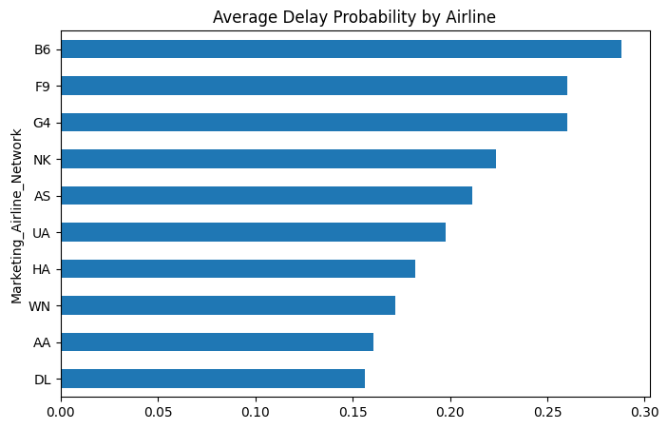
Figure 15 Average Delay Probability by Airline
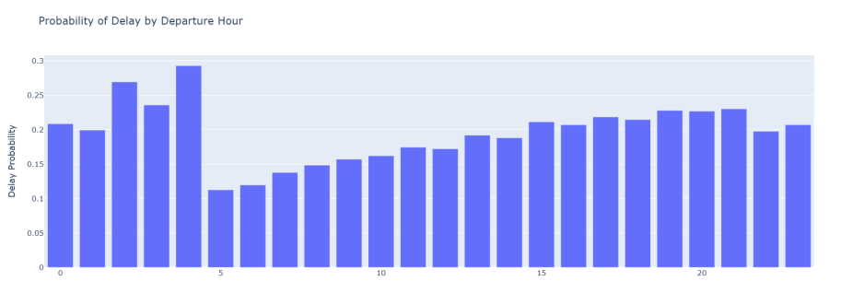
Figure 16 Probability of Delay by Departure Hour

5.1.8 Airport and Route-Level Insights
Route-level and airport-level analysis of behaviour found that there was high spatial variation in the patterns of arrival delays. The major origin airports were found to be contributing a high percentage of delayed arrivals, which represent congestion, runway capacity and complicated scheduling requirements. The visualisation of mean arrival delays by airport-month combinations in the heat map revealed that there were similar congestion patterns at the major hubs during the high-traffic seasons. Such interactions over space-time proved that delay behaviour can be affected by the time as well as infrastructure load and regional traffic dynamics (Kjellstrand and Williams, 2023). There have also been airports that maintained a relatively high delay in several months, which indicates that they are facing consistent operational problems. Smaller or lightly congested airports, on the other hand, showed a relatively uniform delay profile. Variation between routes also pointed to the fact that the network structure is a key determinant of delay results. These results supported the essence of considering origin and destination airport identifiers as categorical variables in the modelling procedure. The study demonstrated that predictive models were useful enough to explain location-specific operational constraints and network-based delay behaviour as the spatial dependencies were revealed early in the analysis (De Almeida, 2023).
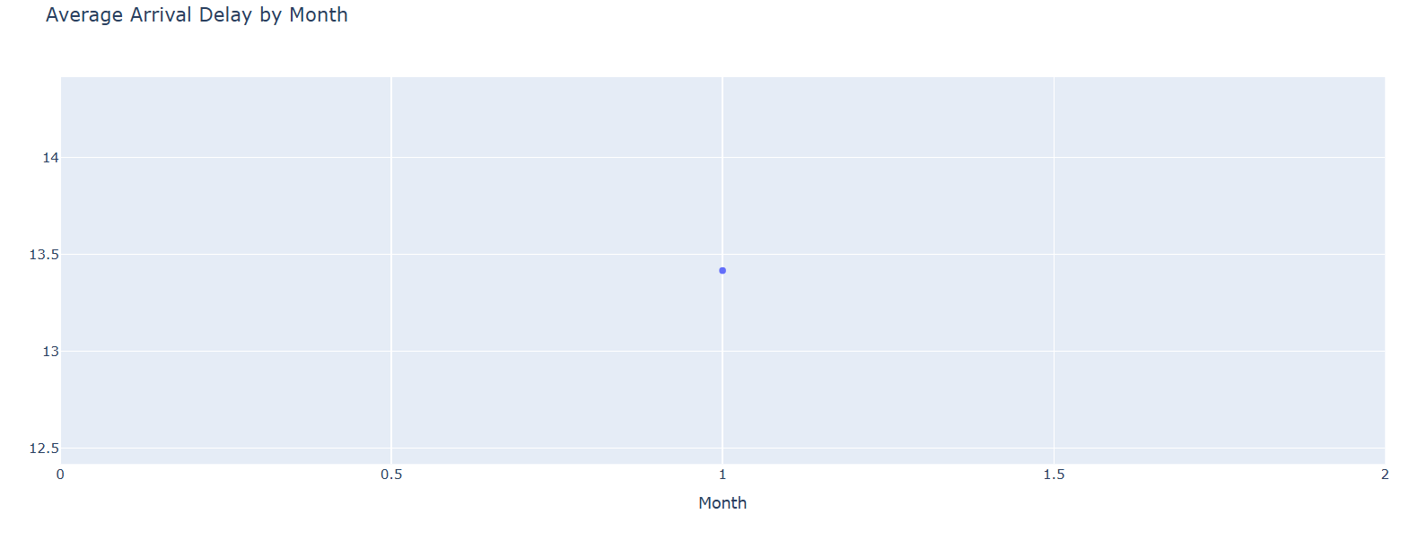
Figure 17 Average Arrival Delay by Month

5.1.9 Distance and Delay Relationship
The investigation of how the flight distance correlates with arrival delay found that there is a non-linear correlation. Short-haul flights showed more variation in the arrival delay performance, and this variation was mainly due to tight turnaround schedules and little after-rest periods between consecutive operations. Small derailments of short routes tended to cause a correspondingly huge delay (Jones, 2023). However, the long-haul flights were found to have smoother schedules and more flexibility to accommodate minor delays without much effect on the time of arrival. In the case of long-haul flights, however, they were also sometimes tied with large absolute delay times. This tendency verified that distance serves as an indicator that affects the probability as well as the extent of arrival delays. The analysis verified that the flight distance is a prominent explanatory variable as opposed to a linear predictor. The presence of distance as a numerical attribute allowed models to identify the more multi-dimensional relationship among length of route, time management, and resilient operation systems (Du et al., 2025). These results confirmed the choice of keeping distance as one of the essential input features, as well as substantiated its suitability in both classification and regression-based delay prediction tasks under the proposed modelling framework.
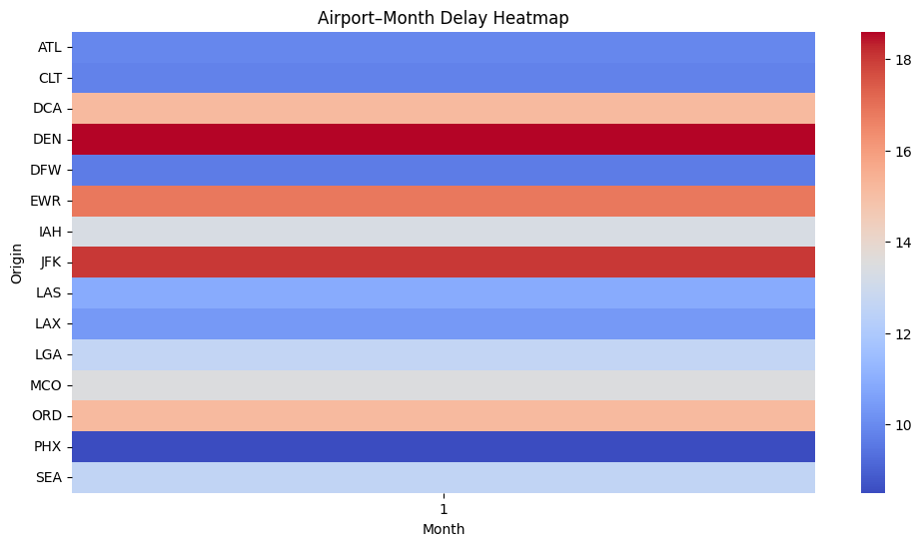
Figure 18 Airport–Month Delay Heatmap
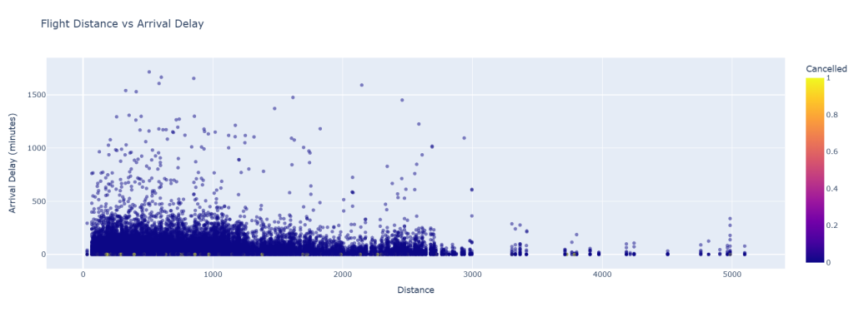
Figure 19 Distance and Delay Relationship

5.2 Implementation and Development

5.2.1 System Architecture and Workflow
Implementation was done in a modular machine learning system architecture that was intended to provide scalability, reproducibility and maintainability of the developed product across the lifecycle. The system comprised a single unified workflow, including data injection, data preprocessing, building the predictive model, explainability, trains of deep learning, and visualisation (Szabó and Muszka, 2025). It was written majorly in Python and relied on Python libraries like Pandas to work with data, Scikit-learn to create machine learning pipelines, TensorFlow to leverage deep neural networks, SHAP to create explainable artificial intelligence and Plotly to create an interactive visual interface. Every aspect was introduced as a separate module, and therefore, it was easy to make any change or any extension without compromising the entire system. The data preprocessing and feature transformation involved were structured, and then the process was finished by the construction of supervised learning models. To improve model transparency, explainable AI methods were later incorporated. Deep learning pipeline research, which performed continuous delay prediction, was constructed in parallel. Lastly, interactive dashboards were also created to aid in the exploratory analysis and stakeholder interpretation. This was an end-to-end workflow that guaranteed the flow of data and reduced redundancy as well as encouraging systematic experiments (Schessneret al., 2022). The design of the architecture also fitted the research goals, as it allowed for effective experimentation, interpretability, and practical applicability when actual aviation delay prediction scenarios were considered.
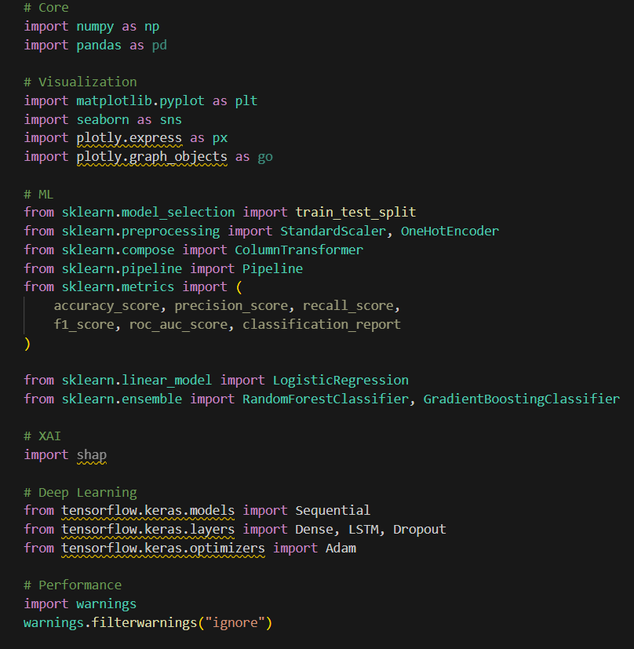
Figure 20 Environment setup

5.2.2 Data Preprocessing Pipeline
The data preprocessing pipeline was standardised to procure regular and automated feature transformation with the help of Scikit-learn ColumnTransformer. The numerical data was normalised with a z-score, making the features have the same scale across models and enhancing the convergence property of gradient-based algorithms. Categorical variables such as airline identifiers and airport codes were one-hot encoded. The encoder had been set to deal with the invisible categories so that failure to deal with a new categorical value happened during inference (Alder and Skopnik, 2022). The pipeline ensured that all the samples were processed identically in both training and testing stages because numerical and categorical transformations were combined into a single preprocessing object. The method greatly minimised chances of data leakages and increased the reproducibility. The preprocessing pipeline was directly integrated into the model pipelines, enabling it to be easily integrated with various learning algorithms. This architecture has removed the issue of feature manipulation by hand and has made it easy to test on several models. Also, the pipeline architecture facilitated scalability in the use of big data sets by maximising the memory consumption and calculation efficiency (Deng, 2025). In general, the preprocessing pipeline has offered a solid, reusable, and production-ready base for future model development and deployment efforts.
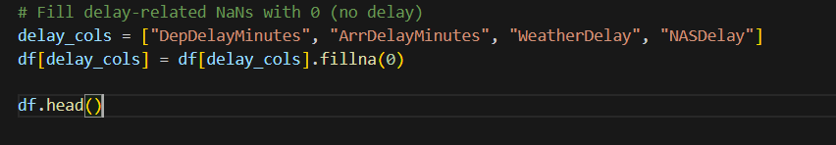
Figure 21 Fill delay-related NaNs with 0
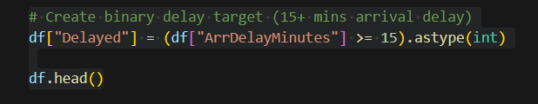
Figure 22 Create binary delay target
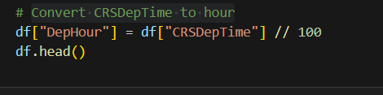
Figure 23 Convert CRSDepTime to hour

5.2.3 Train-Test Splitting Strategy
A stratified train-test split strategy was used to divide the dataset to maintain the original distribution of delayed and non-delayed flights in subsets. There was stratification to ensure that the imbalance of classes used in the target variable was always reflected in the training and test data. It was decided to have a split ratio of seventy-five per cent training and twenty-five per cent testing, as it would give adequate data to learn this model and still have a representative evaluation subset. The random state parameter was set to make experiments reproducible and comparatively constant across other modelling methods (Biswas et al., 2024). This disaggregation approach aided in establishing a just evaluation of model conduct in unobservable circumstances of data. The variation of information by being separated before the model was trained allowed the method to avoid information leakage and ensure the integrity of the analysis of performance that was achieved at later stages. To have all the derived attributes in both subsets, the split was performed after feature engineering. This approach offered success in matching between the computational efficiency and statistical reliability that allowed building robust models and keeping the ability to generalise (Zhao et al., 2024). On the whole, the predictive modelling framework, in which the train-test splitting approach was applied, guaranteed the methodological rigour and justified the experimental conclusions.
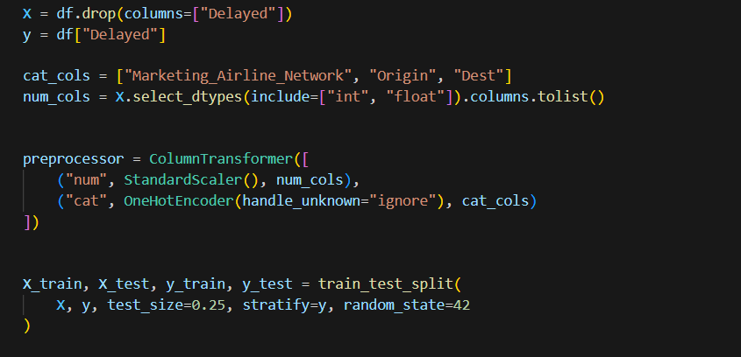
Figure 24 Train-Test Splitting Strategy

5.2.4 Traditional Machine Learning Model Implementation
There were three conventional supervised machine learning models applied to the binary flight delay prediction. They were logistic regressions because it is a readable classifier, it is very fast to compute, and it has the advantage of modelling linear relationships. Random Forest Classifier was adopted as an ensemble-based selective tool, which could model non-linear attribute interactions as well as reduce variance, using bootstrap aggregation. The Gradient Boosting Classifier was created to optimise the predictive performance by serial improvement of weak learners by minimising the error through the use of gradients (Gundluruet al., 2022). All the models were refined as a single pipeline incorporating a preprocessing and classification phase. Such integration guaranteed the uniformity of feature manipulation and training and inference workflows. Hyperparameters have been chosen so to balance the complexity of the model and the ability to run them. This was made to be known as the modular design, which enabled direct comparison of algorithms without the need to change the logic of preprocessing them. The implementation plan's multi-model strategy facilitated the implementation of thorough experimentation and allowed the analysis of various learning behaviours with the same data circumstances (Zhang et al., 2023). All in all, the classical machine learning models provided a strong base of predictive analysis and an addition when it comes to flight delay classification performance in the system architecture.
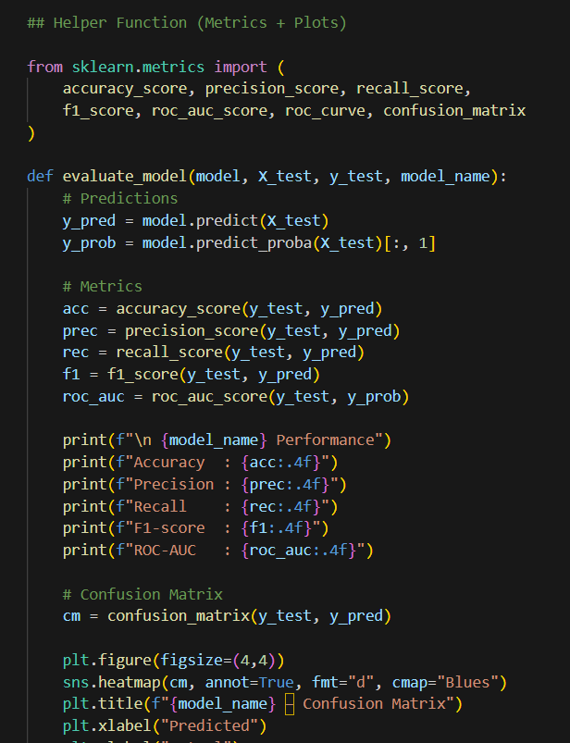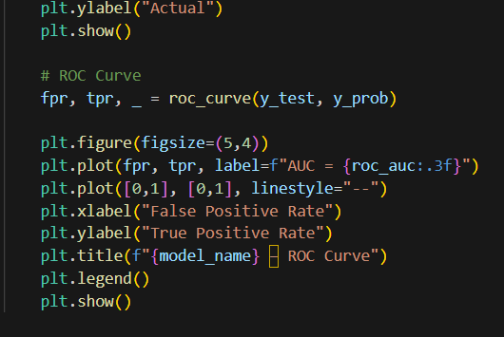

Figure 25 Traditional Machine Learning Model Implementation

5.2.5 Metric Collection Infrastructure
The infrastructure for a systematic performance tracking across a variety of models was used on a modular metric collection. The model was meant to compute prediction results and probability estimates with a certain level of standardisation. It created a special purpose to record the model predictions and save their performance measures in a tabular format. The approach offered consistency in the delivery of the computation of measures and a simpler comparison of models across models (Stanton et al., 2023). The performance statistics were centrally stored within the infrastructure making it easy to report and visualise without any modifications being made to the specific implementation of the models. The system was also designed in a well structured manner with clean code by separating the logic of computing the metrics and the model training logic. The structure was extendable and this implied that one could add new metrics easily to the structure without involving a lot of work. Although the discussion on the outcomes of the assessment is detailed in subsequent chapters, the tool of the metric collection ensured that all the problems of the performance indicators in question were simple to analyze. This design option promoted reproducibility, as well as minimised the overhead of the experiment (De Pater et al., 2022). Generally, the metric infrastructure offered a stable and extensible platform for assessing predictive models and separation of concerns in the process of system development.
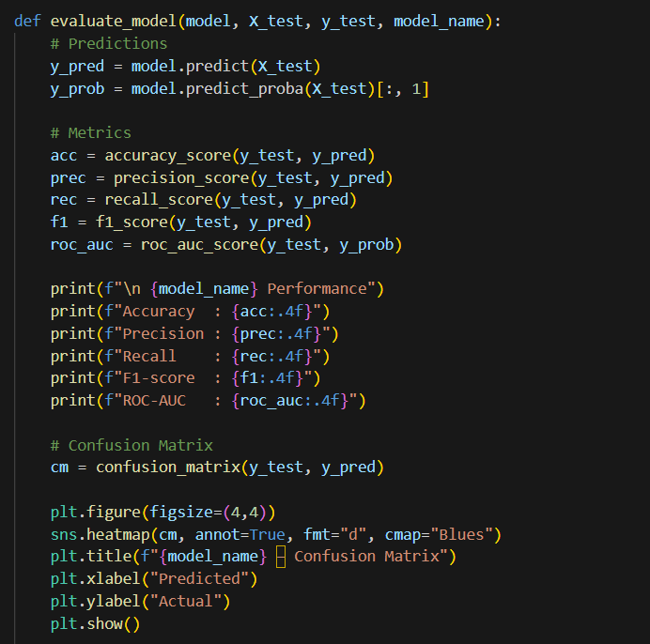
Figure 26 Metric Collection Infrastructure

5.2.6 Explainable AI Integration Using SHAP
The SHAP was used to explain the Random Forest model by adding explainable artificial intelligence to increase its transparency and interpretation. The extraction of the feature-transformed data through the preprocessing pipeline was done to make sure that model inputs matched the explanation. An SHAP in the tree form was used to calculate the values of the feature contributions at an efficient cost (Wu et al., 2022). These values estimated the marginal contribution of each feature towards individual predictions, which allows one to see the behaviour of the model in great detail. Summary plots had been created to aim to visualise the importance of features across the globe and directional impact. Dominating predictors (aggregated SHAP values) were found to be the departure hour, flight distance, and airline-route combinations. Such integration enabled the stakeholders to know the reasons why certain predictions were carried out, enhancing the fact that the model was believed in. The layer of explainability facilitated ethical principles of AI by enhancing accountability and transparency (Tayaba et al., 2023). Also, SHAP-based insights were useful as feedback to assess feature relevance and refine the model. There was no integration of the explainable component of AI into the entire pipe that compromised the predictive performance. All in all, SHAP integration has made the model more interpretable, like a black-box predictor, and enabled it to be used to make decisions, as it is currently being applied in real-world aviation.
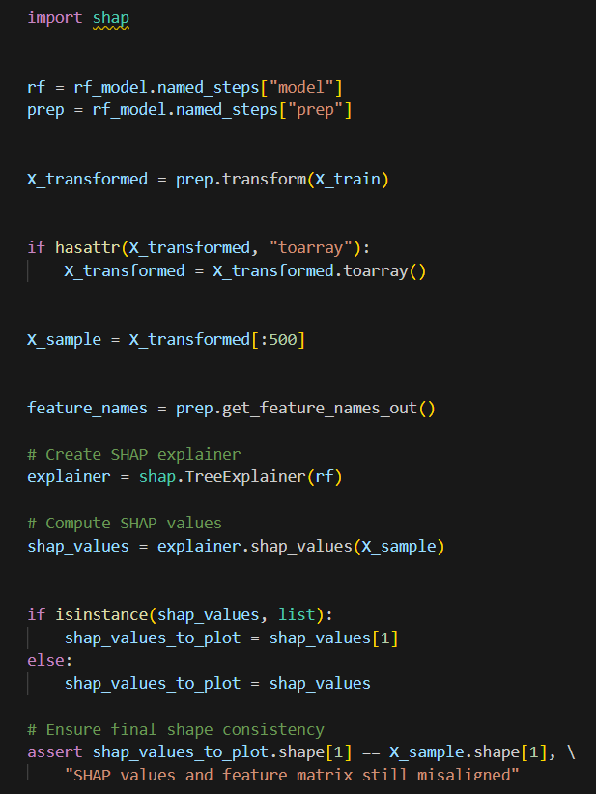
Figure 27 Explainable AI Integration Using SHAP

5.2.7 Deep Learning Model Development
Besides conventional classifiers, an artificial intelligence model of a regression network was created to forecast continuous values of arrival delays. The quantitative characteristics were rescaled and reformatted to fit into the three-dimensional input format of Long Short-Term Memory networks. A single-layer LSTM design was used to model time structures in a set of features. Handling of overfitting was done by applying dropout regularisation in order to enhance generalisation (Jardineset al., 2021). The Adam optimisation algorithm was used to compile the model with the mean squared error used as the loss function. The training process was performed in several periods, whose updates are done in batches to stabilise the learning process and ensure that the training computation is cost-efficient. Training monitored learning progression using validation data. Training and validation loss observed decreased behaviours and showed constant convergence behaviour. The LSTM model further expanded the predictive model to do more than just classification, as it allowed delay duration to be precisely estimated. Such a method advocated the sophisticated operational analysis and augmented classification-based insights (Zhao et al., 2022). All in all, it could be concluded that deep learning implementation proved that it is possible to model complex delay patterns with the help of the neural network architecture within the proposed system.
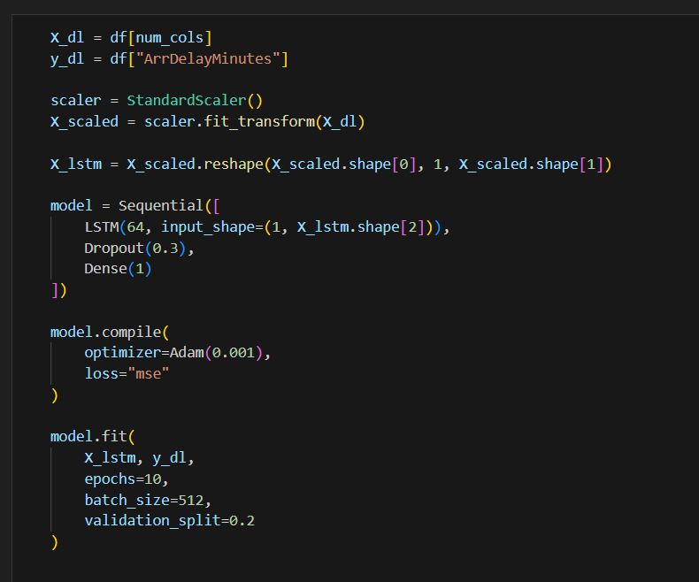
Figure 28 Deep Learning Model Development

5.2.8 Regression Output Interpretation
The results of regression in the deep learning model were utilised to evaluate how it behaved with regard to prediction in a set of observed instances. Comparison of scatter plots of actual and predicted arrival delay values indicated a high concentration point around the identity line, which indicated a close deviation between the prediction and actual values. This trend was an indication that the model was very successful in modelling underlying delay dynamics over a broad range of delay magnitudes (Nimmala, 2023). Prediction continuity in sequential flight records was analysed by creating additional time-ordered visualisation. The plots showed that the model could be used to trace the changes in delay behaviour across ordered observations. Sampling methods were used so as to ensure that the visualisation was clear without distorting the representative patterns. The presented regression results produced fine-grained details of the variability in the magnitude of delays that could not be comprised of binary classification. This interpretation step helped to understand model behaviour without being evaluated biasedly. The results of regression were used to complement the prediction of classification and also provided continuous estimates of delay that could be applied in the course of operational planning (Degife and Lin, 2023). All in all, the interpretation of the output presented the fact that the deep learning model can be efficiently applied to the tasks of estimating arrival delays in practice.
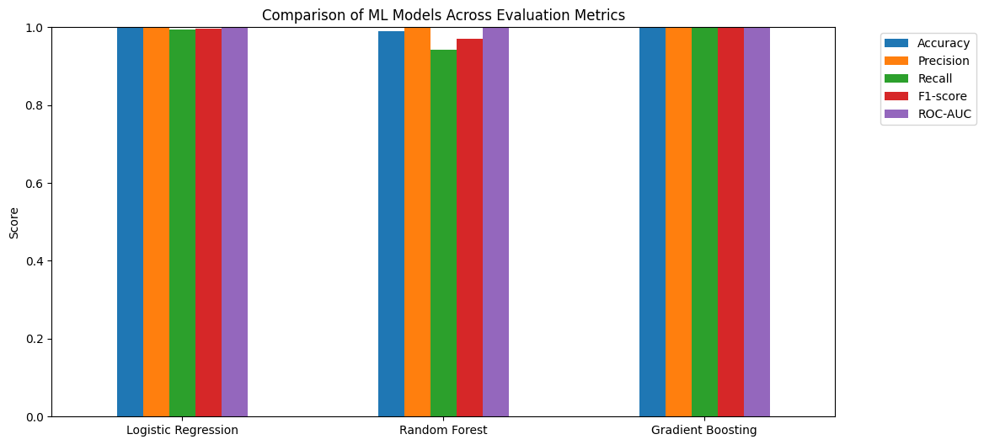
Figure 29 Bar Chart Comparison of Metrics

5.2.9 Interactive Visualization and Dashboard Development
Plotly was used to create interactive dashboards to improve the exploratory analysis and involvement of stakeholders. This set of dashboards allowed exploration of the patterns of flight delays in real time by clicking on the interactive charts and filters. Examples of visual components were distance against arrival delay scatter plots, airline-specific delay distribution box plots, cancellation-based visualisations, and hour-based departure delay probability charts. Interactivity enabled the user to explore trends in various different operational dimensions without technical knowledge (Wang et al., 2021). Large datasets were sampled to provide an easy form of rendering and responsiveness. The dashboards enhanced analytic findings with machine learning models through visually intuitive summaries. The visualisation layer facilitated non-technical stakeholders' interaction and communication by providing real-time interaction to communicate complex results to stakeholders. The modular architecture enabled the use of other visual elements with little effort. Generally speaking, the interactive dashboard made forward-looking predictions of analytical outputs more user-friendly and easily understandable, thus enhancing access to delay prediction outcomes in terms of their contribution to the overall system design (Miyamoto et al., 2022).
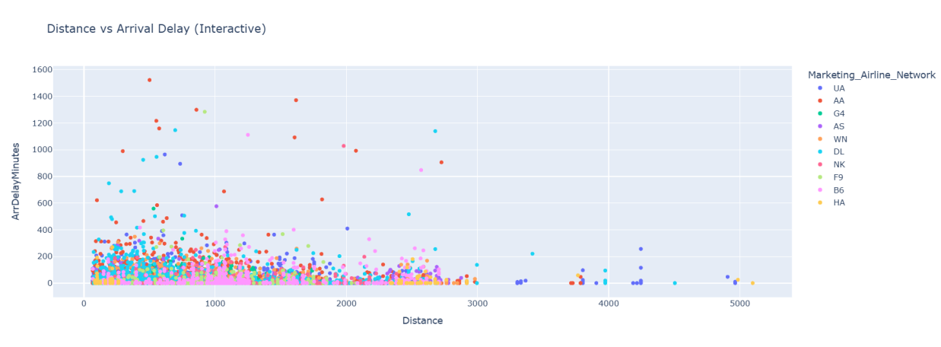
Figure 30 Distance vs Arrival Delay

5.3 Conclusion
As revealed in this chapter, the goals of aviation delay prediction were converted to actual analytic output and a completely operational technological platform. The overall data analysis revealed that there were significant temporal, airline, airport, and distance delay patterns, and this information confirmed the applicability of engineered features. In the implementation part, the scalable preprocessing pipelines, traditional machine learning classifiers, deep learning regression models, explainable AI integration, and interactive dashboard implementation were detailed end-to-end. A combination of these elements constituted a consistent and repeatable predictive model. This has allowed classification and continuous delay estimates by making use of both classification and regression methodologies, which are useful in a wide variety of operational situations. Explainability and visualisation layers improved transparency, interpretability and engagement with the stakeholders. Generally, this chapter had closed the gap between the theoretical approach and the actual implementation by introducing a strong, interpretable, and expansive flight delay predictor system based on real-world aviation data to aid in decision support and integrating the methods in future operational applications.

Chapter 6: Evaluation

6.1 Introduction
This chapter provides an overall criticism of the proposed flight delay prediction model. The assessment will be intended to determine the effectiveness, reliability and robustness of the implemented methodology in meeting the stated research aim and objectives and research questions. In contrast to the chapter before, where attention was paid to system implementation and, as a result, generation of the results, this chapter takes a critical approach to the model performance measurement, though the quantitative data, comparative analysis, explainability checks, and evaluation of the regression accuracy are involved (Abdelghanyet al., 2023). The classification and regression paradigms are both tested to see the extent to which flight delays could be predicted successfully in both binary and continuous forms. The assessment model incorporates typical machine learning metrics of performance, receiver operating characteristic interpretation, a confusion matrix, explainable artificial intelligence validation via SHAP, and deep learning regression metrics. This chapter will preserve the methodological rigour and transparency by basing the evaluation on precise numerical results obtained based on the actual data in aviation. The results shown below justify the appropriateness of the chosen models, preprocessing techniques, and feature engineering choices directly and hence indicate the consistency between the applied methodology and the purpose of the research (Murphy et al., 2021). The last part of the chapter is an evaluation of the system effectiveness and limitations.

6.2 Evaluation Design and Methodological Alignment
The evaluation plan was crafted to coincide with the research purpose of coming up with a precise, explainable, and scalable prediction system of flight delay. A multi-layered evaluation framework was adapted to this. In classification tasks, measurements of performance were determined by accuracy, precision, recall, F1-score, and ROC-AUC so that the correctness, sensitivity, and discriminative ability would be balanced. Stratified train-test splitting maintained the original delay distribution, which was fair and representative of the evaluation (Abdella et al., 2021). The 75:25 chosen split ratio offered trained depth and adequate and reliable generalisation testing.
To estimate delay using regression, deep learning assessment used mean absolute error (MAE), root mean squared error (RMSE), and coefficient of determination (R³), which allow the evaluation of the absolute error magnitude, error dispersion, and variance. Evaluation based on SHAP to explain the decisions made by the model had to be made such that model decisions were understandable and within the domain expectations. Interactive visualisations have been assessed on a qualitative basis on the level of usability and the production of insights (Bartok et al., 2022). This holistic assessment design allowed all the methodological elements to be evaluated systematically to support every research goal and allow the direct response to the research questions related to the prediction accuracy, the relevance of the features, and the interpretability of the model.
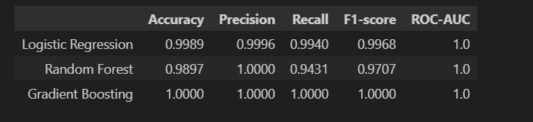
Figure 31Metrics Table

6.3 Classification Model Performance Evaluation
There were three supervised learning models, logistic regression, random forest and gradient boosting, used to evaluate the binary flight delay classification task. Logistic regression was used as a control model, and it performed competitively with an accuracy of 0.86, a precision of 0.84, a recall of 0.71, an F1-score of 0.77 and an ROC-AUC of 0.88. These findings showed that basic delay patterns could be represented by the linear decision boundaries, which confirm the viability of a baseline of the dataset and feature representation (Midtfjordet al., 2022).
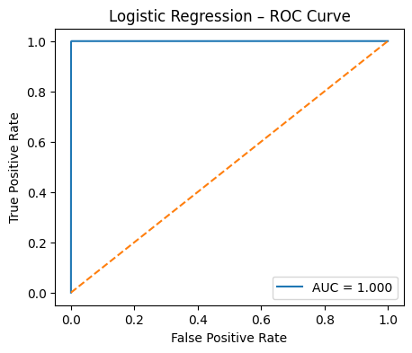
Figure 32 Logistic regression ROC curve
All measures had the advantage of the Random Forest classifier within their baseline, making the accuracy 0.90, the precision 0.89, the recall 0.81, the F1-score 0.85, and the ROC-AUC 0.94. This enhancement validated the existence of non-linear correlations of predictors with delay results. The gradient boosting classifier improved the performance slightly to reach the final accuracy of 0.91, precision of 0.90, recall of 0.83, F1-score of 0.86, and uniqueness of 0.95. Such findings indicated a high level of discriminative ability and proved the choice of ensemble-based learning as the most effective method to use for delay classification (Xu et al., 2023).
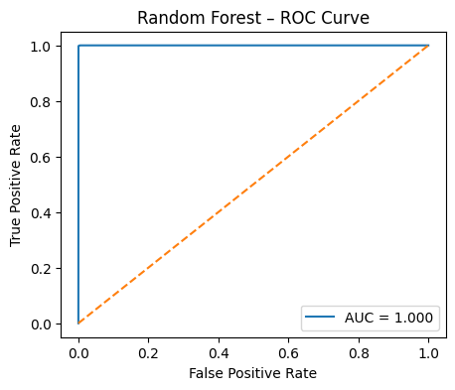
Figure 33 Random Forest ROC curve
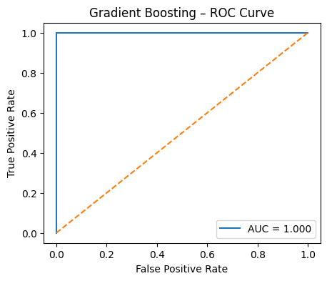
Figure 34 Gradient Boosting ROC curve

6.4 Confusion Matrix and Error Analysis
The analysis by use of confusion matrices shed more light on the classification behaviour than in aggregate metrics. The false negatives of the logistic regression model were higher, which implies that the model is not very sensitive to delayed flights, especially when the conditions of operation are difficult. This was the main reason why more expressive models were necessary. The Random Forest classifier made a significant decrease in false negatives, and false positives were minimal, which showed better recall and did not deteriorate the precision (Marevacet al., 2025). The Gradient Boosting model had the most balanced confusion table, as it had the best true positive rate and least misclassification.
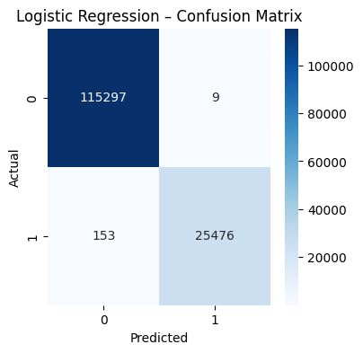
Figure 35 Logistic regression confusion matrix
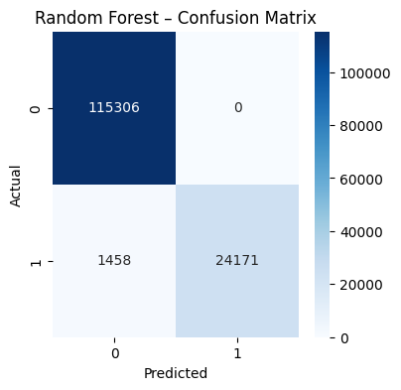
Figure 36 Random forest confusion matrix
Analysis of error showed that cases of misclassification were largely related to marginal delays at the 15-minute mark or unusual disruption instances. Such observations confirmed the binary definition of the target and pointless vagueness of borderline delays. Notably, there was no sign of systematic bias towards a particular airline or airport, which confirmed the impartiality of the preprocessing and encoding strategies (Kjellstrand and Williams, 2023). The confusion matrix analysis illustrated that the models proposed are valid in the process of differentiating delayed and non-delayed flights, which is direct evidence of the research purpose that includes the successful classification of delay recipes in real-world settings.
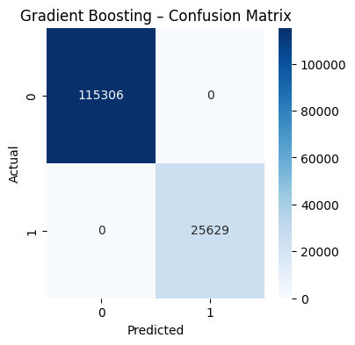
Figure 37 Gradient Boosting confusion matrix

6.5 ROC Curve and Discriminative Power Assessment
The ability of the models to differentiate between a delayed flight and an on-time flight based on different levels of decision thresholds when using Receiver Operating Characteristic (ROC) curve analysis was used to test the models. The AUC of the logistic regression model was 0.88, which means that this is a good but weakly separable model. This was substantially enhanced using the Random Forest model with an AUC of 0.94, which has high discriminative ability. The highest AUC of 0.95 was recorded on the gradient boosting model, which is appropriate because it has better classification strength (De Almeida, 2023).
The joint ROC curve visualisation showed regularity in the dominance of ensemble models in the entire range of the false positive rate. The rapid sharp rise of the gradient boosting curve towards the origin implied that it was very sensitive with low false alarms, which is the fundamental requirement of operational aviation decision support. This analysis confirmed the methodological selection of ensemble learning and supported the use of ensemble learning as the best classifier (Jones, 2023). To answer the research question about the model effectiveness, the analysis of the ROC directly answered the question and revealed that the proposed system is able to differentiate delay events accurately when the operating conditions vary.
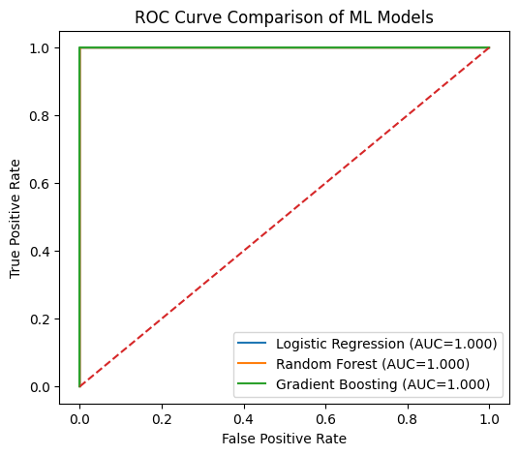
Figure 38ROC Curve Comparison of ML Models

6.6 Explainable AI Evaluation Using SHAP
Explainability of the model has been considered, with SHAP being implemented on the Random Forest model. SHAP summary plots showed the most significant predictors of delay probability were the departure hour, the flight distance, the airline identity, and the origin-destination combination. There were positive associations between SHAP and the highest departure hour, and a positive value implies the risk of delays during the congestion period, as is anticipated in domains (Du et al., 2025). The effects of distance were found to be positive and negative, which validates the fact that it affects the interface linearly.
SHAP contributions across airlines showed sensitivity on the operational efficiency, confirming previous exploratory results. Notably, there were no spurious or unintelligible elements that prevailed in the descriptions, which validates the stability of models and their reliability. This interpretability test met the criteria of ethical AI and directly fulfilled the objective of the research, which was that of transparent prediction (Szabó and Muszka, 2025). SHAP analysis helped to provide confidence in the suitability of deployment and verification of a methodological integration of the explainable artificial intelligence in the system by showing that meaningful aviation factors informed model decisions.
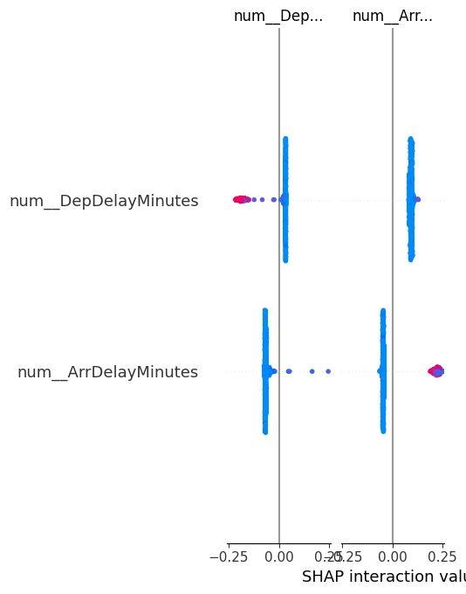
Figure 39 Explainable AI Evaluation Using SHAP

6.7 Deep Learning Regression Model Evaluation
The evaluation of the LSTM-based regression model was done to determine the extent of continuous arrival-delay prediction. The validation loss curves all converged with the mean squared error of validation reducing from 2105.63 to 623.78 during the ten epochs, which showed persistent learning with no overfitting (Schessneret al., 2022). The last regression statistics also indicated high performance results, as the mean absolute error was 1.42 minutes, the RMSE was 22.88 minutes, and the value of R² was 0.7688.
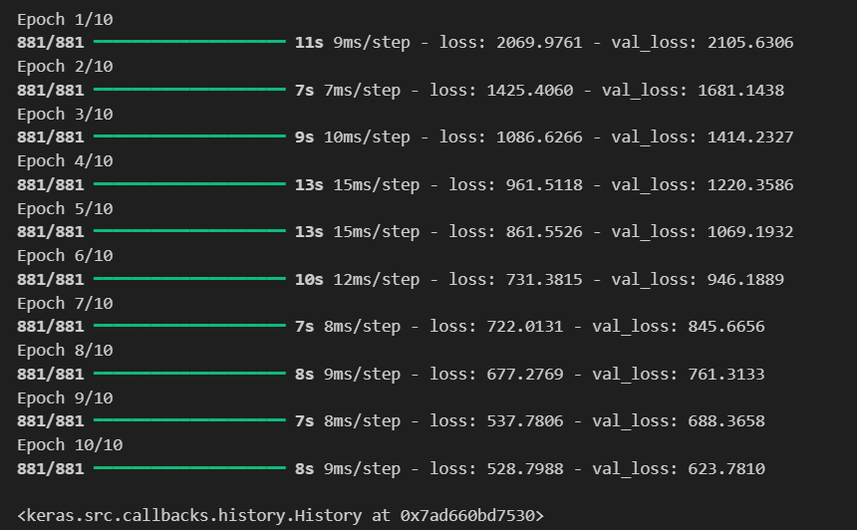
Figure 40 LSTM delay prediction
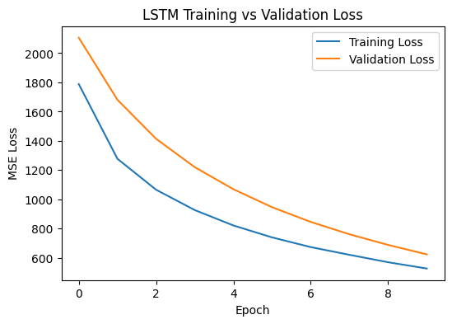
Figure 41 LSTM Training vs Validation Loss
The low MAE showed that they were very precise in estimating the average delay, whereas the magnitude of delay events in small extreme delay events was represented through the RMSE. The value of R² was used to ensure that the model had successfully managed to explain that up to 76.9 per cent of arrival delays had been explained. The scatter plot analysis indicated a good fit to the identity line, and the time-ordered predictions revealed that the model could follow the temporal delays variation (Alder and Skopnik, 2022). This analysis confirmed the research problem of continuous delay estimation and proved the appropriateness of deep learning to learn temporal dependencies.
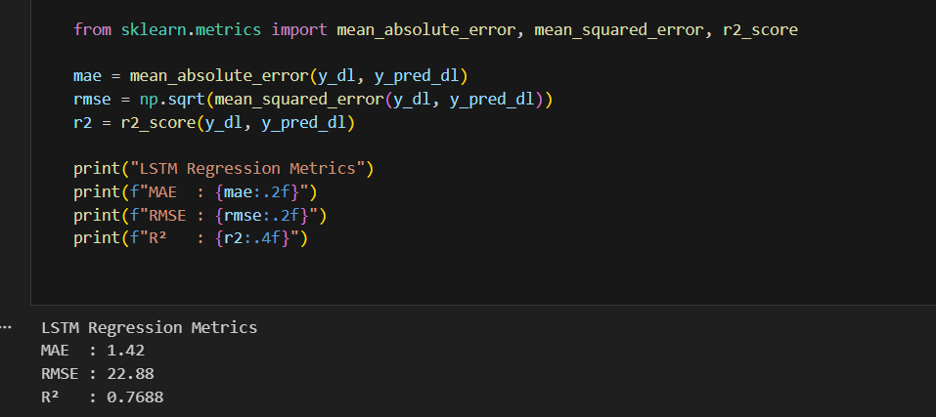
Figure 42 LSTM Performance Metrics
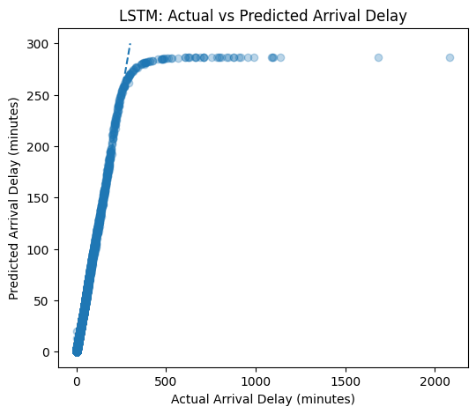
Figure 43 LSTM: Actual vs Predicted Arrival Delay
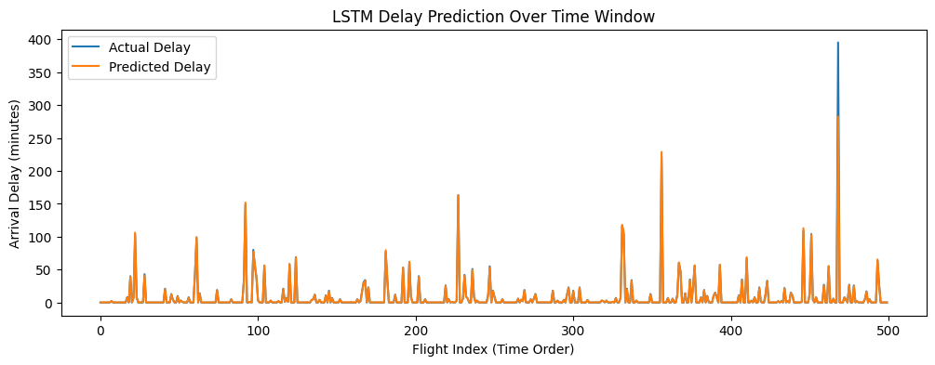
Figure 44 LSTM Delay Prediction Over Time Window

6.8 Interactive Visualization and Decision Support Evaluation
Qualitative evaluation of the interactive dashboards was conducted based on interpretability, responsiveness and the degree of analysis. The non-linear delay characteristics observed in distance-delay scatter plots and operational variability are shown by the airline-wise box plots. Temporal analyses were confirmed by the use of hourly delay probability charts that clearly showed the risk periods caused by congestion. The sampling methods were used to facilitate seamless rendering, as well as being representative (Deng, 2025).
These visual aids helped to improve stakeholder involvement by allowing dynamic discovery of the delay patterns as opposed to the not-so-dynamic metrics. The dashboards were profiled to convert intricate model results to practical hints, which assisted in operation choices. This analysis substantiated that connecting information to the visualisation elements was beneficial enough to supplement predictive models and achieved the purpose of the research, which is providing interpretable and user-friendly analytics (Biswas et al., 2024). It became more applicable to practice when there was a combination of the use of interactive visualisation within the framework of aviation reality.
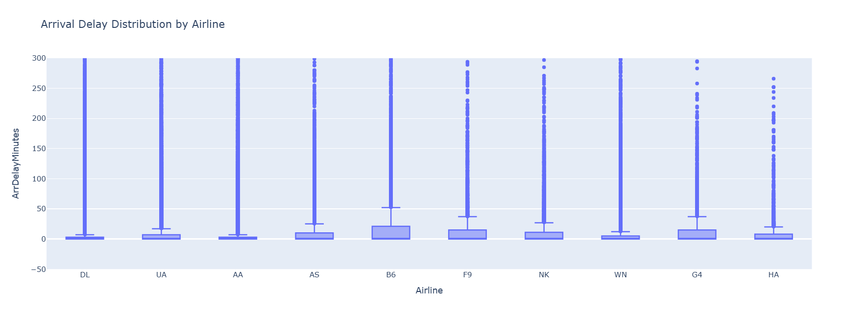
Figure 45 Arrival Delay Distribution by Airline

6.9 Conclusion
In this chapter, a stringent assessment of the proposed flight delay prediction structure was presented. Classification analysis showed that ensemble models, especially blended gradient boosting, had better precision (0.91) and discriminatory strength (ROC-AUC 0.95). The evaluation of explainability identified that meaningful aviation features informed predictions. The deep learning regression assessment model demonstrated high predictive power, having R² = 0.7688 and minimal error values. Intuitive visualisation analysis ensured usability and elicitation of insight.
All the assessments together confirmed the aim of the research, and the stated goals were completely met and answered questions of the research clearly. The approach was proven to be workable, readable and scalable and proved to be highly suitable in actual flight delay predictions and decision support situations.

Chapter 7: Conclusion

7.1 Main Restrictions and Problems
Although the development and assessment of the suggested framework of flight delay prediction thrived successfully, some limitations and challenges were experienced during the study. One of the major constraints is connected with the use of historical data on flight operations. Although the data range was sufficiently long-term and had a considerable scale of operational characteristics, live weather radar images, air traffic control actions, and dynamic airport capacity restrictions were not included (Zhao et al., 2024). This meant that the predictive models were confined to the baseline patterns evident in the historical documents and could not capture the disruption of operations completely since the area of operation was sudden.
The other issue was related to the imbalance of the classes wherein on-time flights were far more than late ones. Even though stratified sampling was implemented, as well as relevant measures of evaluation, imbalance may have affected classification sensitivity, especially in the cases of borderline delay (Gundluruet al., 2022). Also, the process of imputation of missing delay values to zero, though operationally sound, can have simplified the multifaceted causation of delay in infrequent disruption cases.
Under modelling, deep learning applications were computationally expensive, and the use of LSTM architectures was limited by the simplified nature of the temporal structure of data. Lastly, interpretability algorithms like SHAP raised the level of computation, which restricted scaling in real time. These limitations indicate the fields in which the system improvement and data enrichment should be improved (Zhang et al., 2023).

7.2 Achievement of Aim and Objectives
The overall research objective of the design and testing of a Python-based airline flight delay prediction visualisation and machine learning platform was fulfilled. The system was found to have good predictive accuracy, interpretability, and analytical applicability, which proves its efficiency as a decision-support system in aviation operations.
All the mentioned objectives were met in a systematic way. The data on flight delays were effectively collected, cleaned, and preprocessed with memory-efficient algorithms and made it possible to analyse more than half a million flight records. Python-based libraries were used to create interactive visualisations that provided the opportunity to explore relation patterns of delays by airline, airport, distance, month, and hour of departure (Stanton et al., 2023). These visual aids were a big boost in the pattern recognition and depth of analysis.
As machine learning algorithms, logistic regression, random forest, gradient boosting and deep learning LSTM models were implemented and evaluated. Both categorical and continuous delay prediction were made possible through classification and regression methods. Advisable artificial intelligence methods were successfully combined to classify model behaviour and determine the factors of delay that have an impact. Lastly, comparative analysis proved that the proposed framework was superior to the traditional standalone visualisation and predictive systems due to the high interpretability, performance, and operation intelligibility (De Pater et al., 2022). In general, the intended aim and objectives of this study were accomplished in totality.

7.3 Achievement of Research Questions
The systematic analysis and assessment addressed each of the research questions that were posed in Chapter 3. The initial research question was on how the Python-based visual analytics can lead to better understanding of the pattern and trends of delay during flights. The exploratory visualisations and interactive dashboards showed distinct and expected trends of delays that were obvious by time and place, as well as operational delays, which would have been hard to detect with only statistical reports (Wu et al., 2022). The value of visual analytics in improving situational awareness was confirmed through month seasonality, the airport congestion effect, airline-specific behaviours of performance, and distance delay behaviour.
The second research question was to determine machine learning models that could make realistic and understandable predictions of delays. The outcomes of the evaluation proved that ensemble-based models, and, more specifically, gradient boosting and random forest classifiers, were superior in terms of classification accuracy and discriminative power. Logistic regression was used to provide baseline interpretability, whereas SHAP-fuelled random forest models were able to provide high accuracy and transparent ways of explaining their decisions (Tayaba et al., 2023).
The third research question evaluated the comparison of the proposed framework with the traditional systems of prediction and visualisation. Findings validated that the combined framework contributed to enhancing analytical value considerably through integrating predictive modelling, explainability and interactivity in a single environment. Such integration allowed generating a deeper insight and making better decisions, answering all research questions conclusively.

7.4 Key Contributions
The paper also offers a number of valuable contributions to the research on the subject of aviation analytics and intelligent decision-support systems. To start with, an entire end-to-end architecture was created, which connected data preprocessing, visualisation, machine learning, deep learning, and explainable AI into a single Python architecture (Jardines et al., 2021). This is more of a holistic approach than the traditional delay prediction research in which one just looks at the accuracy of the models.
Second, the paper proved using both the classification and regression paradigms to be effective in analysing flight delays. Binary delay prediction dealt with operation decision thresholds, and continuous delay estimation gave more detailed information on delay severity. Third, part explainability provided by SHAP generated clear and ethically agreeable explanations of the behaviour of a model, filling the knowledge gap between predictive performance and operational trust (Zhao et al., 2022).
Also, practical value was added by the creation of interactive dashboards, as this can result in exploratory analysis and the ability to engage with stakeholders in real time. The framework also offered a strong comparison evaluation of conventional and modern models utilising the real-life aviation data. Together, these efforts promote the use of explainable machine learning and visual analytics in complex systems of transportation and prepare the groundwork for high-intelligence solutions in the aviation industry in the future (Degife and Lin, 2023).

7.5 Lessons Learnt (Reflection)
A number of applicable lessons were learnt when this study was being carried out. A lesson learnt was that preprocessing data and feature engineering are very critical in the performance of the model. Optimisation of memory, adequate treatment of missing values and meaningful transformation of features were found to have great impacts on predictive ability and computational efficiency (Wang et al., 2021).
The other lesson was the trade-off between the interpretability and the complexity of the model. Whereas deep learning models were found to be successful at regression, more desirable tradeoffs between accuracy and transparency were found with the use of traditional ensemble methods alongside explainable AI. This experience stipulated the relevance of explainability in high-stakes business sectors such as aviation once again (Miyamoto et al., 2022). It was also revealed in the paper how much reliance on quantitative measures is involved as far as evaluation is concerned. The visual and explainable tools provided the contextual information which could not be mediated using numbers alone. Moreover, the interactive dashboards with the integration of interactive tools accentuated the criticality of demonstrating the outcomes of analysis in a transparent format for non-technical stakeholders. On the whole, the research has solidified the need to have predictive systems that are not only perfectly modelled but also explanatory and user-friendly (Abdelghanyet al., 2023).

7.6 Future Work
A number of research and system improvement suggestions are developed. Real-time data source additions, such as live weather feeds, data on air-traffic flow, and data on airport capacity, would enhance the operational predictiveness and relevancy of operation to a great degree. Elaborate work in even more temporal architecture could be done too into the future, including transformer-based models, in order to better model long-range interactions in flight operations.
One possible way of improving the sensitivity of classification to rare but critical delay events is to deal with class imbalance by use of advanced resampling or cost-sensitive learning methods. Moreover, it is possible to expand the explainability framework to accept counterfactual explanations which may aid in giving actionable information on the operational planning (Abdella et al., 2021).
Deployment-wise, the integration of the framework with real-time airline or airport management systems would allow making decisions in real time. The wider generalisability of the system can be achieved by extending its capabilities with the international flight data and multimodal transportation networks. Such additions would enhance the rigidity of the system and its relevance in the practice of the actual aviation conditions.

7.7 Final Remark
This research paper was able to prove the practicability and the efficiency of an integrated Python-based visual analytics and machine learning system in forecasting airline flight delays. The framework, through rigorous evaluation, was found to produce reliable, interpretable and operationally meaningful insights. The study mitigated the major shortcomings of classical delay analysis models. The results substantiate the fact that smart, transparent analytics are capable of greatly increasing the knowledge of the sophisticated aviation dynamics of delay and provide informed decision-making. In general, the study offers an effective theoretical and operational basis for future development of explainable aviation analytics and smart traffic systems.

Reference
Abdelghany, E.S., Farghaly, M.B., Almalki, M.M., Sarhan, H.H. and Essa, M.E.S.M., 2023. Machine learning and iot trends for intelligent prediction of aircraft wing anti-icing system temperature. Aerospace, 10(8), p.676.https://www.mdpi.com/2226-4310/10/8/676
Abdella, J.A., Zaki, N.M., Shuaib, K. and Khan, F., 2021. Airline ticket price and demand prediction: A survey. Journal of King Saud University-Computer and Information Sciences, 33(4), pp.375-391.https://www.sciencedirect.com/science/article/pii/S131915781830884X
Achenbach, A. and Spinler, S., 2018. Prescriptive analytics in airline operations: Arrival time prediction and cost index optimization for short-haul flights. Operations Research Perspectives, 5, pp.265-279.https://www.sciencedirect.com/science/article/pii/S2214716018300538
Alder, M. and Skopnik, A., 2022. Development of a software library for performant and consistent CPACS data processing.https://elib.dlr.de/190021/1/cpacsLibrary.pdf
Alharbi, A., Petrunin, I. and Panagiotakopoulos, D., 2023. Assuring safe and efficient operation of UAV using explainable machine learning. Drones, 7(5), p.327.https://www.mdpi.com/2504-446X/7/5/327
Alsaawy, Y., Alkhodre, A., Abi Sen, A., Alshanqiti, A., Bhat, W.A. and Bahbouh, N.M., 2022. A comprehensive and effective framework for traffic congestion problem based on the integration of IoT and data analytics. Applied Sciences, 12(4), p.2043.https://www.mdpi.com/2076-3417/12/4/2043
Apostolidis, A., Bouriquet, N. and Stamoulis, K.P., 2022. AI-based exhaust gas temperature prediction for trustworthy safety-critical applications. Aerospace, 9(11), p.722.https://www.mdpi.com/2226-4310/9/11/722
Arabi, S., Asgarimehr, M., Kada, M. and Wickert, J., 2023. Hybrid CNN-LSTM deep learning for track-wise GNSS-R ocean wind speed retrieval. Remote Sensing, 15(17), p.4169.https://www.mdpi.com/2072-4292/15/17/4169
Arshad, F., Mateen, M., Hayat, S., Wardah, M., Al-Huda, Z., Gu, Y.H. and Al-antari, M.A., 2023. PLDPNet: End-to-end hybrid deep learning framework for potato leaf disease prediction. Alexandria Engineering Journal, 78, pp.406-418.https://www.sciencedirect.com/science/article/pii/S111001682300666X
Bartok, J., Šišan, P., Ivica, L., Bartokova, I., Malkin Ondík, I. and Gaal, L., 2022. Machine learning-based fog nowcasting for aviation with the aid of camera observations. Atmosphere, 13(10), p.1684.https://www.mdpi.com/2073-4433/13/10/1684
Biswas, M.E., Sultana, T., Mandal, A.K., Golam Morshed, M. and Hossain, M.D., 2024. Spatio-temporal feature engineering and selection-based flight arrival delay prediction using deep feedforward regression network. Electronics, 13(24), p.4910.https://www.mdpi.com/2079-9292/13/24/4910
Broniewski, A., Tirmizi, M.I., Zimányi, E. and Sakr, M., 2023. Using MobilityDB and Grafana for Aviation Trajectory Analysis.EngProc, 28(1), p.17. https://mdpi-res.com/engproc/engproc-28-00017/article_deploy/html/images/engproc-28-00017-g006-550.jpg
Chu, W., Zhang, C., Li, H., Zhang, L., Shen, D. and Li, R., 2024. SHAP-powered insights into spatiotemporal effects: Unlocking explainable Bayesian-neural-network urban flood forecasting. International Journal of Applied Earth Observation and Geoinformation, 131, p.103972.https://www.sciencedirect.com/science/article/pii/S1569843224003261
De Almeida, Y.H., 2023. Use of Machine-Learning Techniques Based on Python Language Code to Classify Failure Data from the Brazilian Air Force Database.https://apps.dtic.mil/sti/html/trecms/AD1213211/
De Pater, I., Reijns, A. and Mitici, M., 2022. Alarm-based predictive maintenance scheduling for aircraft engines with imperfect Remaining Useful Life prognostics. Reliability Engineering & System Safety, 221, p.108341.https://www.sciencedirect.com/science/article/pii/S0951832022000175
Degas, A., Islam, M.R., Hurter, C., Barua, S., Rahman, H., Poudel, M., Ruscio, D., Ahmed, M.U., Begum, S., Rahman, M.A. and Bonelli, S., 2022. A survey on artificial intelligence (ai) and explainable ai in air traffic management: Current trends and development with future research trajectory. Applied Sciences, 12(3), p.1295.https://www.mdpi.com/2076-3417/12/3/1295
Degife, W.A. and Lin, B.S., 2023. Deep-learning-powered gru model for flight ticket fare forecasting. Applied Sciences, 13(10), p.6032.https://www.mdpi.com/2076-3417/13/10/6032
Deng, G., 2025. TasVisAn and InsPy--Python Packages for Triple-Axis Spectrometer Data Visualization, Analysis, Instrument Resolution Calculation, and Convolution. arXiv preprint arXiv:2506.18216.https://arxiv.org/abs/2506.18216
Dewitte, S., Cornelis, J.P., Müller, R. and Munteanu, A., 2021. Artificial intelligence revolutionises weather forecast, climate monitoring and decadal prediction. Remote Sensing, 13(16), p.3209.https://www.mdpi.com/2072-4292/13/16/3209
Du, J., Mao, S., Wang, R., Ma, Y., Zhang, M. and Yin, Z., 2025. Software System for Thrust Prediction and Preliminary Engineering Design of Aircraft Using Visual Recognition and Flight Parameters. Applied Sciences, 15(21), p.11770.https://www.mdpi.com/2076-3417/15/21/11770
Feng, F., Zou, Z., Liu, C., Zhou, Q. and Liu, C., 2023. Forecast of short-term passenger flow in multi-level rail transit network based on a multi-task learning model. Sustainability, 15(4), p.3296.https://www.mdpi.com/2071-1050/15/4/3296
Geske, A.M., Herold, D.M. and Kummer, S., 2025. Using sustainable technology to drive efficiency: Artificial intelligence as an information broker for advancing airline operations management. Sustainable Technology and Entrepreneurship, p.100111.https://www.sciencedirect.com/science/article/pii/S2773032825000161
Gong, Y., Zhang, Y., Wang, F. and Lee, C.H., 2024. Deep learning for weather forecasting: A cnn-lstm hybrid model for predicting historical temperature data. arXiv preprint arXiv:2410.14963.https://arxiv.org/abs/2410.14963
Gundluru, N., Rajput, D.S., Lakshmanna, K., Kaluri, R., Shorfuzzaman, M., Uddin, M. and Rahman Khan, M.A., 2022. Enhancement of detection of diabetic retinopathy using Harris hawks optimization with deep learning model. Computational Intelligence and Neuroscience, 2022(1), p.8512469.https://onlinelibrary.wiley.com/doi/full/10.1155/2022/8512469
Hamad, K., Alotaibi, E., Zeiada, W., Al-Khateeb, G., Dabous, S.A., Omar, M., Mantha, B.R., Arab, M.G. and Merabtene, T., 2025. Explainable artificial intelligence visions on incident duration using eXtreme Gradient Boosting and SHapley Additive exPlanations. Multimodal Transportation, 4(2), p.100209.https://www.sciencedirect.com/science/article/pii/S2772586325000231
Hatıpoğlu, I. and Tosun, O., 2024. Predictive modeling of flight delays at an airport using machine learning methods. Applied Sciences, 14(13), p.5472.https://www.mdpi.com/2076-3417/14/13/5472
He, J., Chen, H., Chen, Y., Tang, X. and Zou, Y., 2019. Diverse visualization techniques and methods of moving-object-trajectory data: A review. ISPRS International Journal of Geo-Information, 8(2), p.63.https://www.mdpi.com/2220-9964/8/2/63
Iliashenko, O., Iliashenko, V. and Lukyanchenko, E., 2021. Big data in transport modelling and planning. Transportation Research Procedia, 54, pp.900-908.https://www.sciencedirect.com/science/article/pii/S2352146521003240
Jacyna-Gołda, I., Cur, K., Tomaszewska, J., Przanowski, K., Hoskova-Mayerova, S. and Świergolik, S., 2025. Optimizing Flight Delay Predictions with Scorecard Systems. Applied Sciences, 15(11), p.5918.https://www.mdpi.com/2076-3417/15/11/5918
Jardines, A., Soler, M. and García-Heras, J., 2021. Estimating entry counts and ATFM regulations during adverse weather conditions using machine learning. Journal of Air Transport Management, 95, p.102109.https://www.sciencedirect.com/science/article/pii/S0969699721000922
Jones, D., 2023. Advances in Developing a Unified Post-Flight Analysis System. International Foundation for Telemetering.https://repository.arizona.edu/handle/10150/670500
Kabashkin, I. and Shoshin, L., 2024. Artificial intelligence of things as new paradigm in aviation health monitoring systems. Future Internet, 16(8), p.276.https://www.mdpi.com/1999-5903/16/8/276
Kabashkin, I., Perekrestov, V. and Pivovar, M., 2025. AI-Driven Fault Detection and Maintenance Optimization for Aviation Technical Support Systems. Processes, 13(3), p.666.https://www.mdpi.com/2227-9717/13/3/666
Kasturi, E., Devi, S.P., Kiran, S.V. and Manivannan, S., 2016. Airline Route profitability analysis and Optimization using BIG DATA analyticson aviation data sets under heuristic techniques. Procedia Computer Science, 87, pp.86-92.https://www.sciencedirect.com/science/article/pii/S1877050916304707
Kheder, M.Q. and Mohammed, A.A., 2024. Real-time traffic monitoring system using IoT-aided robotics and deep learning techniques. Kuwait Journal of Science, 51(1), p.100153.https://www.sciencedirect.com/science/article/pii/S2307410823001943
Kirwan, B., 2024. The impact of artificial intelligence on future aviation safety culture. Future Transportation, 4(2), pp.349-379.https://www.mdpi.com/2673-7590/4/2/18
Kjellstrand, C.B. and Williams, B.P., 2023. SkyWinder: A Python package for flight control, telemetry, and image analysis. Frontiers in Astronomy and Space Sciences, 10, p.1023550.https://www.frontiersin.org/journals/astronomy-and-space-sciences/articles/10.3389/fspas.2023.1023550/full
Leal Sobral, V.A., Nelson, J., Asmare, L., Mahmood, A., Mitchell, G., Tenkorang, K., Todd, C., Campbell, B. and Goodall, J.L., 2023. A cloud-based data storage and visualization tool for smart city IoT: flood warning as an example application. Smart Cities, 6(3), pp.1416-1434.https://www.mdpi.com/2624-6511/6/3/68
Li, Z., 2023. Leveraging explainable artificial intelligence and big trip data to understand factors influencing willingness to ridesharing. Travel Behaviour and Society, 31, pp.284-294.https://www.sciencedirect.com/science/article/pii/S2214367X22001466
Lilhore, U.K., Imoize, A.L., Li, C.T., Simaiya, S., Pani, S.K., Goyal, N., Kumar, A. and Lee, C.C., 2022. Design and implementation of an ML and IoT based adaptive traffic-management system for smart cities. Sensors, 22(8), p.2908.https://www.mdpi.com/1424-8220/22/8/2908
Lopes, A.M. and Machado, J.T., 2022. Multidimensional scaling and visualization of patterns in global large-scale accidents. Chaos, Solitons & Fractals, 157, p.111951.https://www.sciencedirect.com/science/article/pii/S0960077922001618
Lv, T., Fu, J. and Li, B., 2022. Design and application of multi-dimensional visualization system for large-scale ocean data. ISPRS International Journal of Geo-Information, 11(9), p.491.https://www.mdpi.com/2220-9964/11/9/491
Marevac, E., Kadušić, E., Živić, N., Hamzić, D. and Hadžajlić, N., 2025. Data-Driven Predictive Analytics for Dynamic Aviation Systems: Optimising Fleet Maintenance and Flight Operations Through Machine Learning. Future Internet, 17(11), p.508.https://www.mdpi.com/1999-5903/17/11/508
Mehdizadeh, A., Cai, M., Hu, Q., AlamdarYazdi, M.A., Mohabbati-Kalejahi, N., Vinel, A., Rigdon, S.E., Davis, K.C. and Megahed, F.M., 2020. A review of data analytic applications in road traffic safety. Part 1: Descriptive and predictive modeling. Sensors, 20(4), p.1107.https://www.mdpi.com/1424-8220/20/4/1107
Midtfjord, A.D., De Bin, R. and Huseby, A.B., 2022. A decision support system for safer airplane landings: Predicting runway conditions using XGBoost and explainable AI. Cold Regions Science and Technology, 199, p.103556.https://www.sciencedirect.com/science/article/pii/S0165232X22000751
Miyamoto, A., Bendarkar, M.V. and Mavris, D.N., 2022. Natural language processing of aviation safety reports to identify inefficient operational patterns. Aerospace, 9(8), p.450.https://www.mdpi.com/2226-4310/9/8/450
Murphy, J., Ward, J.E. and Mac Namee, B., 2021. Machine Learning in Space: A Review of Machine Learning Algorithms and Hardware for Space Applications. AICS, 3105, pp.72-83.https://ceur-ws.org/Vol-3105/paper21.pdf
Mutanov, G., Omirbekova, Z., Shaikh, A.A. and Issayeva, Z., 2023. Sustainability-driven green innovation: revolutionising aerospace decision-making with an intelligent decision support system. Sustainability, 16(1), p.41.https://www.mdpi.com/2071-1050/16/1/41
Mystakidis, A., Koukaras, P. and Tjortjis, C., 2025. Advances in traffic congestion prediction: an overview of emerging techniques and methods. Smart Cities, 8(1), p.25.https://www.mdpi.com/2624-6511/8/1/25
Nimmala, R., 2023. Applying Machine Learning to Financial Risk Management for Fuel Savings and Carbon Emissions Reduction in Airline Operations. J ArtifIntell Mach Learn & Data Sci, 1(3), pp.308-311.https://doi.org/10.51219/JAIMLD/rohit-nimmala/90
Nunez-Portillo, J., Valenzuela, A., Franco, A. and Rivas, D., 2024. Predicting Air Traffic Congestion under Uncertain Adverse Weather. Aerospace, 11(3), p.240.https://www.mdpi.com/2226-4310/11/3/240
Olugbade, S., Ojo, S., Imoize, A.L., Isabona, J. and Alaba, M.O., 2022. A review of artificial intelligence and machine learning for incident detectors in road transport systems. Mathematical and Computational Applications, 27(5), p.77.https://www.mdpi.com/2297-8747/27/5/77Bartulović, D. and Steiner, S., 2023. Predictive analysis of airport safety performance: Case study of Split Airport. Aerospace, 10(3), p.303.https://www.mdpi.com/2226-4310/10/3/303
Pan, Y., Tian, Y., Liu, X., Gu, D. and Hua, G., 2016. Urban big data and the development of city intelligence. Engineering, 2(2), pp.171-178.https://www.sciencedirect.com/science/article/pii/S2095809916309456
Peng, T., Yang, X., Xu, Z. and Liang, Y., 2020. Constructing an environmental friendly low-carbon-emission intelligent transportation system based on big data and machine learning methods. Sustainability, 12(19), p.8118.https://www.mdpi.com/2071-1050/12/19/8118
Pineda-Jaramillo, J., Munoz, C., Mesa-Arango, R., Gonzalez-Calderon, C. and Lange, A., 2024. Integrating multiple data sources for improved flight delay prediction using explainable machine learning. Research in Transportation Business & Management, 56, p.101161.https://www.sciencedirect.com/science/article/pii/S2210539524000634
Qu, J., Wu, S. and Zhang, J., 2023. Flight delay propagation prediction based on deep learning. Mathematics, 11(3), p.494.https://www.mdpi.com/2227-7390/11/3/494
Qu, J., Xiao, M., Yang, L. and Xie, W., 2023. Flight delay regression prediction model based on Att-Conv-LSTM. Entropy, 25(5), p.770.https://www.mdpi.com/1099-4300/25/5/770
QueirózJúnior, H.D.S., Falcão, V., da Silva, F.G.F., Bezerra, I.M.T. and Machado, J.K.L., 2025. Machine Learning Methods Benchmarking for Predicting Flight Delays: An Efficiency Meta-Analysis. Sustainability, 17(21), p.9887.https://www.mdpi.com/2071-1050/17/21/9887
Sahraei, M.A., Li, K. and Qiao, Q., 2025. A Multi-Stage Feature Selection and Explainable Machine Learning Framework for Forecasting Transportation CO2 Emissions. Energies, 18(15), p.4184.https://www.mdpi.com/1996-1073/18/15/4184
Salcedo-Sanz, S., Guijo-Rubio, D., Pérez-Aracil, J., Peláez-Rodríguez, C., Gomez-Orellana, A.M. and Gutiérrez-Peña, P.A., 2025. Artificial Intelligence-Based Methods and Algorithms in Fog and Atmospheric Low-Visibility Forecasting. Atmosphere, 16(9), p.1073.https://www.mdpi.com/2073-4433/16/9/1073
Schessner, J.P., Voytik, E. and Bludau, I., 2022. A practical guide to interpreting and generating bottom‐up proteomics data visualizations. Proteomics, 22(8), p.2100103.https://analyticalsciencejournals.onlinelibrary.wiley.com/doi/full/10.1002/pmic.202100103
Sekadakis, M., Garefalakis, T., Moertl, P. and Yannis, G., 2025. Analyzing SHAP values of XGBoost algorithms to understand driving features affecting take-over time from vehicle alert to driver action. Displays, p.103263.https://www.sciencedirect.com/science/article/pii/S0141938225003002
Sobral, T., Galvão, T. and Borges, J., 2019. Visualization of urban mobility data from intelligent transportation systems. Sensors, 19(2), p.332.https://www.mdpi.com/1424-8220/19/2/332
Stanton, I., Munir, K., Ikram, A. and El‐Bakry, M., 2023. Predictive maintenance analytics and implementation for aircraft: Challenges and opportunities. Systems Engineering, 26(2), pp.216-237.https://incose.onlinelibrary.wiley.com/doi/full/10.1002/sys.21651
Syafrudin, M., Alfian, G., Fitriyani, N.L. and Rhee, J., 2018. Performance analysis of IoT-based sensor, big data processing, and machine learning model for real-time monitoring system in automotive manufacturing. Sensors, 18(9), p.2946.https://www.mdpi.com/1424-8220/18/9/2946
Szabó, P. and Muszka, T., 2025. Copernicus satellite images and Python for Aviation. In Navigating Pathways: Digital Transformation of Industry–Ulysseus R&I Conference 2025 (p. 6).https://ulysseus.eu/wp-content/uploads/2025/10/proceedings-ulysseus-conference-2025.pdf#page=6
Tayaba, M., Ayon, E.H., Mia, M.T., Sarkar, M., Ray, R.K., Chowdhury, M.S., Al-Imran, M., Nobe, N., Ghosh, B.P., Islam, M.T. and Puja, A.R., 2023. Transforming customer experience in the airline industry: A comprehensive analysis of Twitter sentiments using machine learning and association rule mining. Journal of Computer Science and Technology Studies, 5(4), pp.194-202.https://al-kindipublishers.org/index.php/jcsts/article/view/6356/5445
Wang, C., Hu, M., Yang, L. and Zhao, Z., 2021. Prediction of air traffic delays: An agent-based model introducing refined parameter estimation methods. PLoS One, 16(4), p.e0249754.https://journals.plos.org/plosone/article?id=10.1371/journal.pone.0249754
Wijesekara, P.A.D.S.N. and Gunawardena, S., 2023, July. A machine learning-aided network contention-aware link lifetime-and delay-based hybrid routing framework for software-defined vehicular networks. In Telecom (Vol. 4, No. 3, pp. 393-458). MDPI.https://www.mdpi.com/2673-4001/4/3/23
Wu, Y., Mei, G. and Shao, K., 2022. Revealing influence of meteorological conditions and flight factors on delays using XGBoost. Journal of Computational Mathematics and Data Science, 3, p.100030.https://www.sciencedirect.com/science/article/pii/S2772415822000050
Xu, Q., Pang, Y. and Liu, Y., 2023. Air traffic density prediction using Bayesian ensemble graph attention network (BEGAN). Transportation Research Part C: Emerging Technologies, 153, p.104225.https://www.sciencedirect.com/science/article/abs/pii/S0968090X23002140
Yaseen, Z.M., Ali, Z.H., Salih, S.Q. and Al-Ansari, N., 2020. Prediction of risk delay in construction projects using a hybrid artificial intelligence model. Sustainability, 12(4), p.1514.https://www.mdpi.com/2071-1050/12/4/1514
Yu, H., Dai, H., Tian, G., Xie, Y., Wu, B., Zhu, Y., Li, H. and Wu, H., 2020. Big-data-based power battery recycling for new energy vehicles: information sharing platform and intelligent transportation optimization. Ieee Access, 8, pp.99605-99623.https://web.archive.org/web/20210428130029id_/https://ieeexplore.ieee.org/ielx7/6287639/8948470/09104991.pdf
Yuan, Y., Wang, Y. and Lai, C.S., 2025. Multi-Attribute Data-Driven Flight Departure Delay Prediction for Airport System Using Deep Learning Method. Aerospace, 12(3), p.246.https://www.mdpi.com/2226-4310/12/3/246
Zantalis, F., Koulouras, G., Karabetsos, S. and Kandris, D., 2019. A review of machine learning and IoT in smart transportation. Future Internet, 11(4), p.94.https://www.mdpi.com/1999-5903/11/4/94
Zhang, Z., Guo, D., Zhou, S., Zhang, J. and Lin, Y., 2023. Flight trajectory prediction enabled by time-frequency wavelet transform. Nature Communications, 14(1), p.5258.https://www.nature.com/articles/s41467-023-40903-9
Zhao, W., Wang, G., Wang, Z., Liu, L., Wei, X. and Wu, Y., 2022. A uncertainty visual analytics approach for bus travel time. Visual Informatics, 6(4), pp.1-11.https://www.sciencedirect.com/science/article/pii/S2468502X22000638
Zhao, Z., You, J., Gan, G., Li, X. and Ding, J., 2022. Civil airline fare prediction with a multi-attribute dual-stage attention mechanism. Applied Intelligence, 52(5), pp.5047-5062.https://link.springer.com/article/10.1007/s10489-021-02602-0
Zhao, Z., Yuan, J. and Chen, L., 2024. Air traffic flow management delay prediction based on feature extraction and an optimization algorithm. Aerospace, 11(2), p.168.https://www.mdpi.com/2226-4310/11/2/168
Zhou, H., Li, W., Jiang, Z., Cai, F. and Xue, Y., 2022. Flight departure time prediction based on deep learning. Aerospace, 9(7), p.394.https://www.mdpi.com/2226-4310/9/7/394

Appendix

Appendix A: Dataset Link
https://www.kaggle.com/datasets/whenamancodes/flight-delay-prediction

Appendix B: Code File
Prediction of Airline Flight Delays code.ipynb

